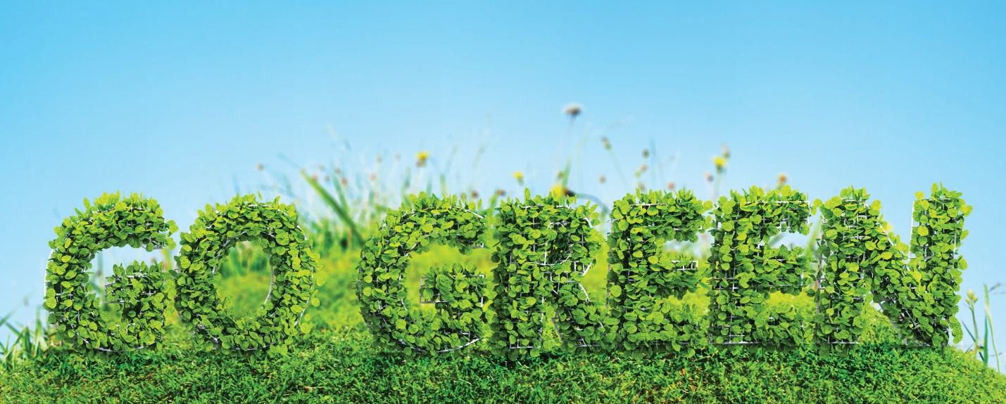

Go Green this Ramadan
To celebrate the tenth Green Ramadan Campaign, this year ISNA will be offering $500, $300, and $200 awards to three mosques that exemplify the best Green Ramadan
Ramadan is a great time to remember our responsibility to care for and protect Earth, which, by Allah’s grace, provides the food we need to sustain a healthy life. Interacting mindfully with our environment and within our ecosystem is a manifestation of faith. As we fast, let’s reaffirm our sense of self-restraint, ethics of conservation and accountability to make this Ramadan both spiritually and environmentally better.
For several years ISNA Green Initiative has provided a rubric as guidance for environmentally friendly practices by individuals and communities. The rubric is available on https://isna.net/greeninitiative. Please download it and use it during Ramadan and later. In recognition of this effort, the Green Initiative Team, through the courtesy of Pen and Ink Pot Foundation, will again plant a tree on your behalf at a place needing trees. Your Islamic center or mosque will also receive a certificate of achievement. After Ramadan ends, please email your contact information and details of your achievements of following the rubric to isnagreenmasjid@gmail.com.
Alhamd-u-Lillah, for the past ten years, the ISNA Green Initiative Team has been encouraging mosques, Islamic centers, schools, homes, and individuals to adopt environmentally friendly practices. To celebrate this tenth Green Ramadan Campaign, ISNA will be offering $500, $300, and $200 awards to three mosques that exemplify the best Green Ramadan. The relevant details and the nomination form will be communicated through ISNA’s website and digital media later.

