Science, Done Right!
Qamar Madani
Brighter Horizons Academy

Abstract

This workshop will give teachers ideas on making Science engaging for students with a variety of hands on activities, games, puzzles and projects. Students learn the most from applying knowledge and the highest form of learning is creating experiences with the knowledge/content at hand. Science is best learned for enduring understanding when students are involved in their learning experience. Join this session if you are as excited as I to teach science in the out of the box kind of way. This workshop is intended to provide educators immediate strategies to implement the very next day in their classrooms.

Hands on Learning is more powerful in the classroom, and there is no question about it! Hands-on is minds-on! Hands-on projects engage all different types of learners. They obviously engage kids who are tactile or kinesthetic learners, who need movement to learn best. They also engage students who are auditory learners, who talk about what they're doing, and visual learners, who have the opportunity to see what everyone else is creating.
I think the best example to outline why hands on learning is hugely important is when trying to teach someone to ride a bicycle. You can try and teach them in a classroom, but to actually learn, they have to go out and actually ride it.
Students who physically experience scientific concepts understand them more deeply and score better on science tests, according to a new UChicago-led study. Brain scans showed that students who took a hands-on approach to learning had activation in sensory and motor-related parts of the brain when they later thought about concepts such as angular momentum and torque. Activation of these brain areas was associated with better quiz performance by college physics students who participated in the research.
While it is appropriate to introduce older students to science history and expect them to learn facts discovered by others, young children should learn science (and all other areas of study) through active involvement – that is, through first-hand, investigative experiences. Young children should be involved in “sciencing” versus the learning of scientific facts presented by others (Kilmer & Hofman, 1995; Mayesky, 1998; Zeece, 1999). Sciencing is a verb and suggests active involvement. Such involvement should be both hands-on and minds-on in nature. Thus, children should be engaged both physically and mentally in investigating and manipulating elements in their environment (Chaille & Britain, 2003; Kilmer & Hofman, 1995).
Therefore, science for young children should involve asking questions, probing for answers, conducting investigations, and collecting data. Science, rather than being viewed as the memorization of facts, becomes a way of thinking and trying to understand the world. This approach allows children to become engaged in the investigative nature of science (Kilmer & Hofman, 1995; Lind, 1999) and to experience the joy of having wonderful ideas (Duckworth, 1987).
Inquiry-based science adopts an investigative approach to teaching and learning where students are provided with opportunities to investigate a problem, search for possible solutions, make observations, ask questions, test out ideas, and think creatively and use their intuition. In this sense, inquiry-based science involves students doing science where they have opportunities to explore possible solutions, develop explanations for the phenomena under investigation, elaborate on concepts and processes, and evaluate or assess their understandings in the light of available evidence. This approach to teaching relies on teachers recognizing the importance of presenting problems to students that will challenge their current conceptual understandings so they are forced to reconcile anomalous thinking and construct new understandings. (Gillies, Dr. Robyn)

Performance Tasks
A performance task is any learning activity or assessment that asks students to perform to demonstrate their knowledge, understanding and proficiency. Performance tasks yield a tangible product and/or performance that serve as evidence of learning.
Here are some general characteristics of performance tasks, according to Jay McTighe, professor at Columbia:

- Performance tasks call for the application of knowledge and skills, not just recall.
- Performance tasks are open-ended, do not yield a single, correct answer.
- Performance tasks establish novel and authentic contexts for performance.
- Performance tasks provide evidence of understanding via transfer.
- Performance tasks are multi-faceted.
- Performance tasks can integrate two or more subjects Performances on open-ended tasks are evaluated with established criteria and rubrics.

Examples:

Rube Goldberg project – Students demonstrate their knowledge of principles in physics by designing, creating, and explaining a Rube Goldberg device.

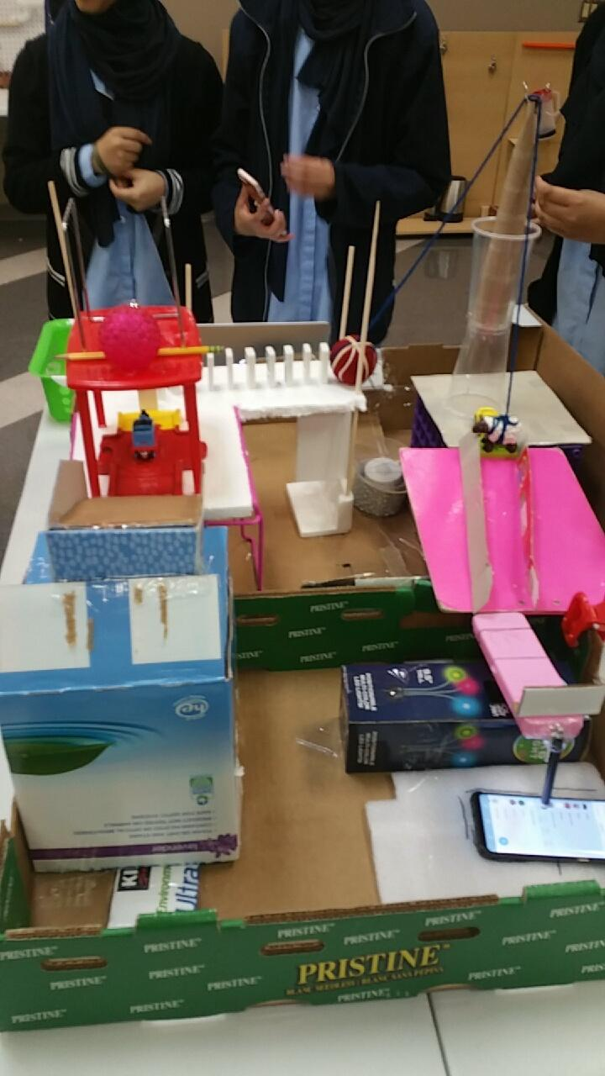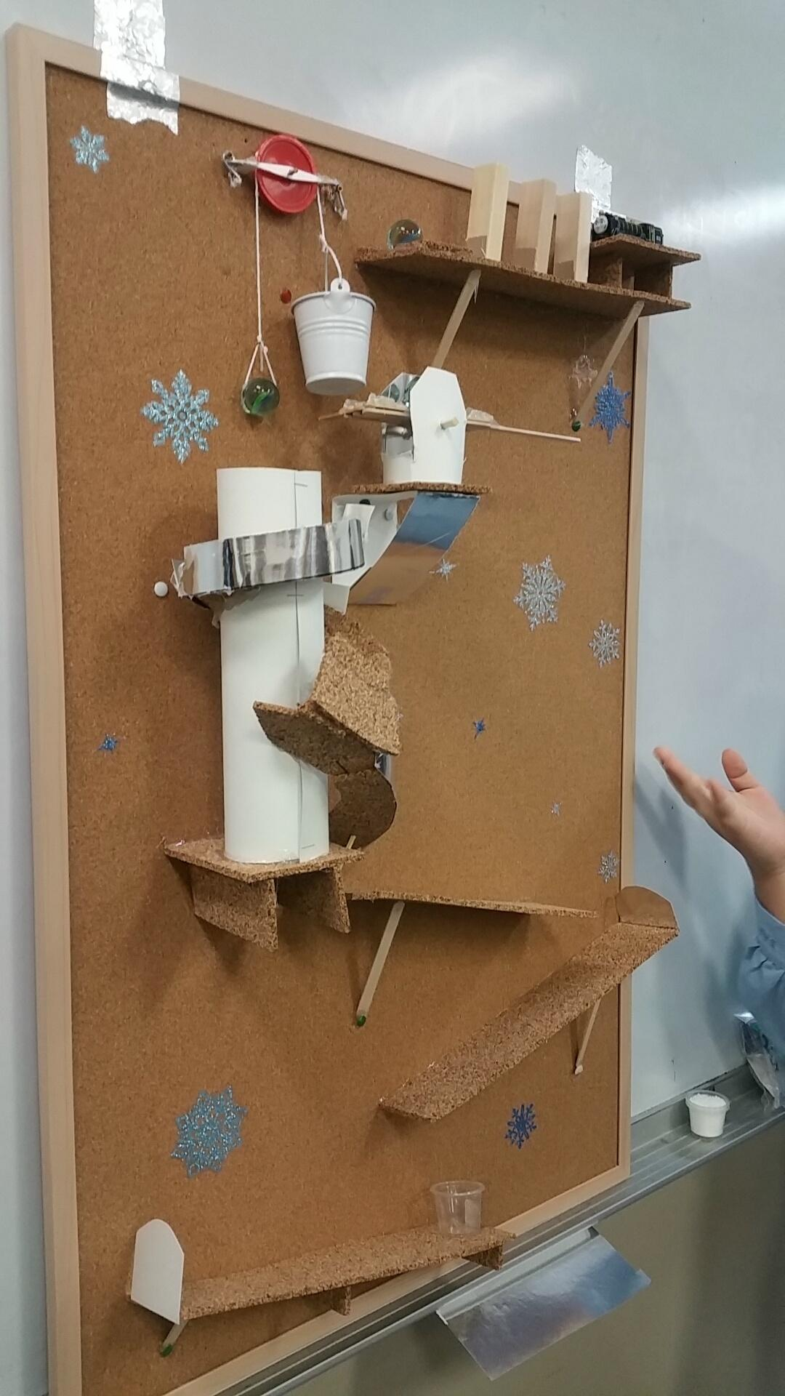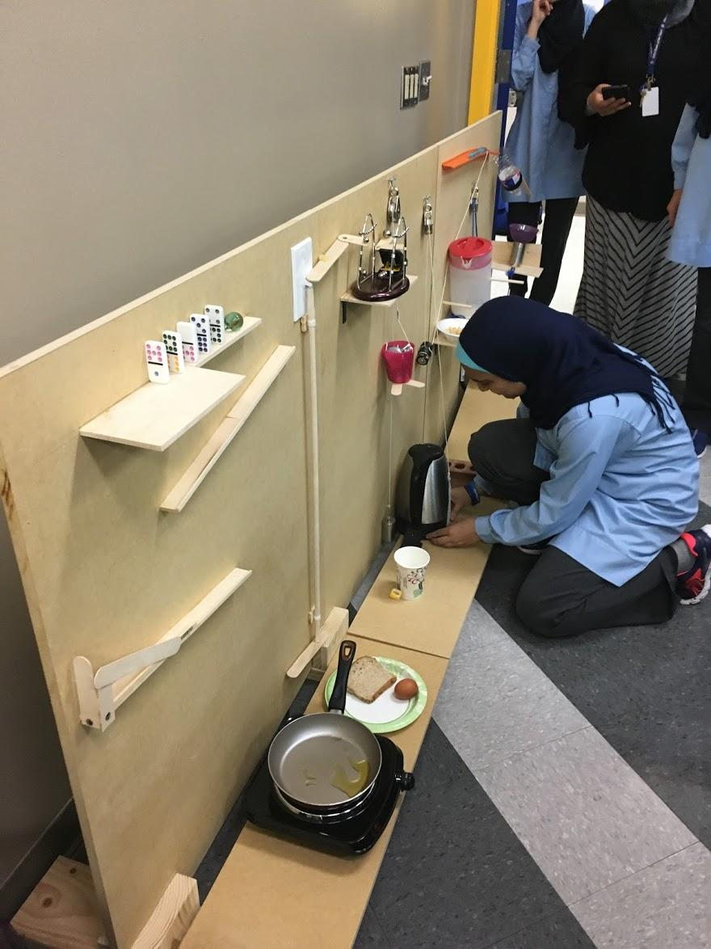

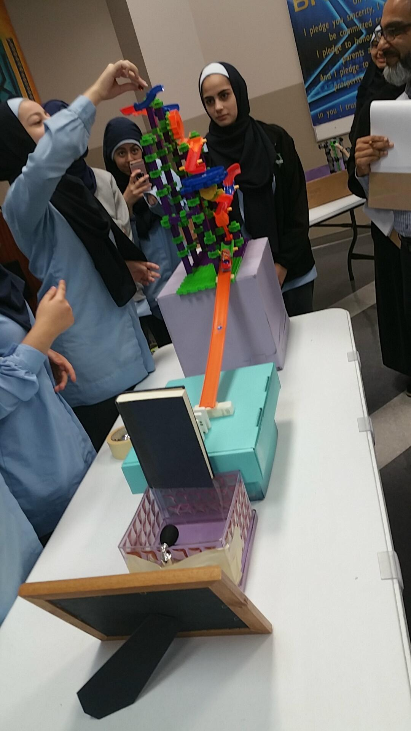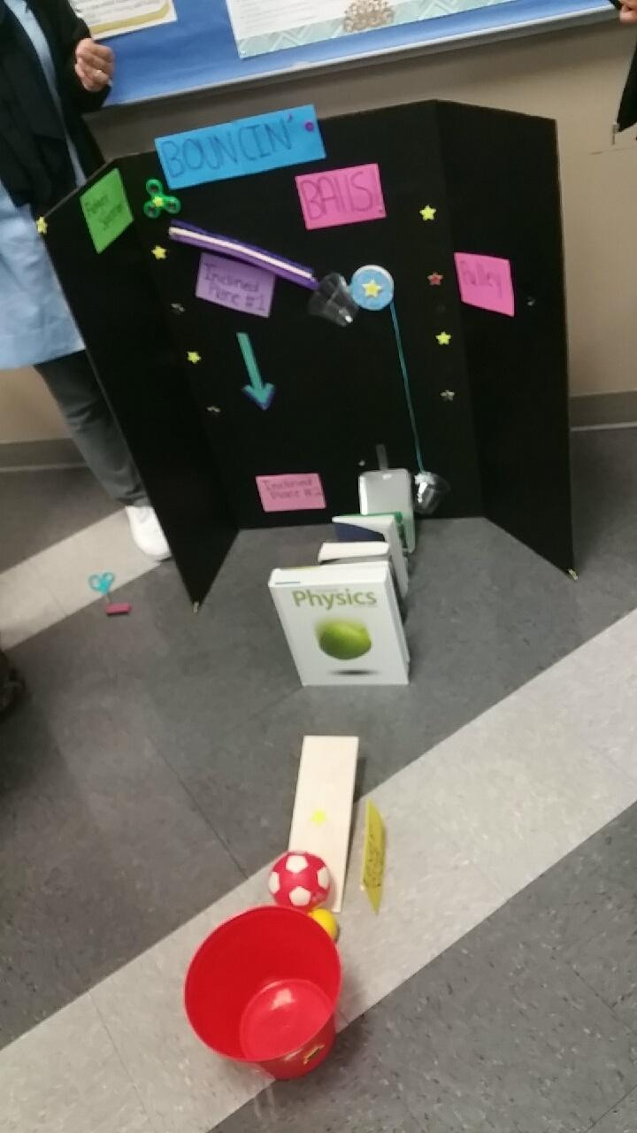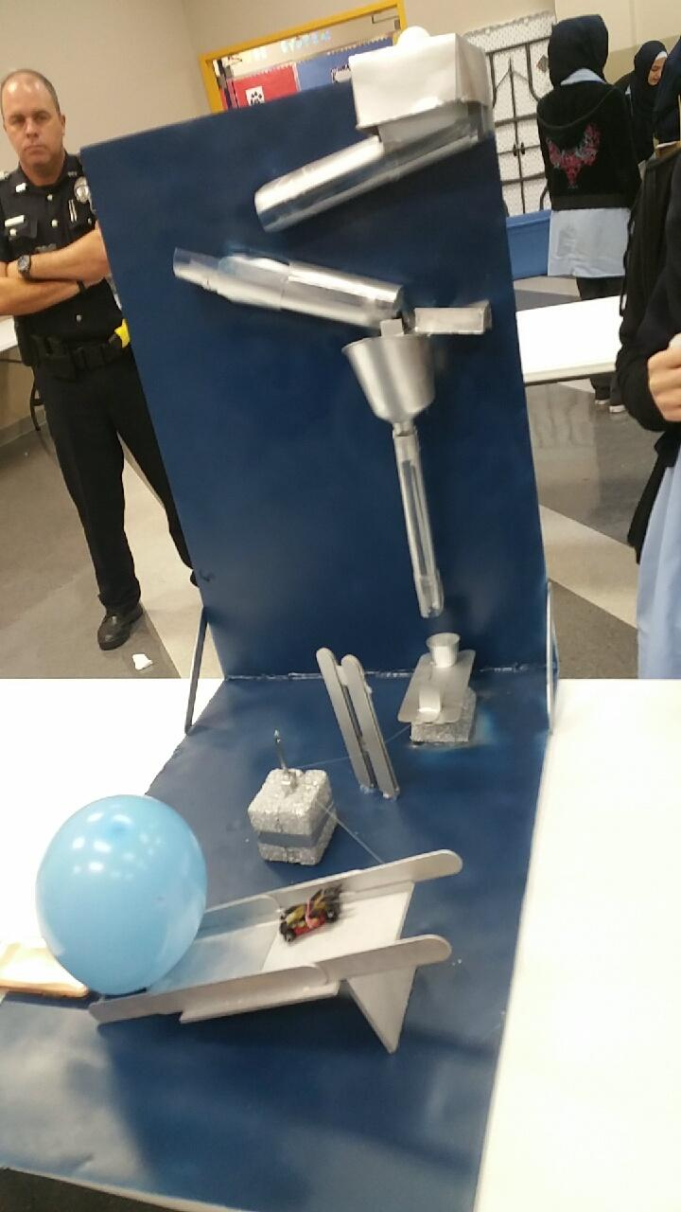

Egg drop project - Students demonstrate the knowledge of momentum and impulse by making a device that will keep a raw egg from breaking.

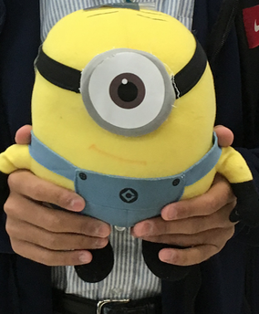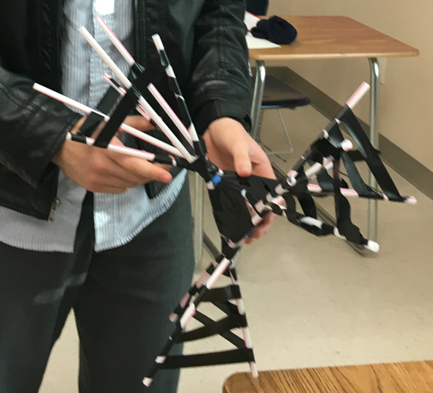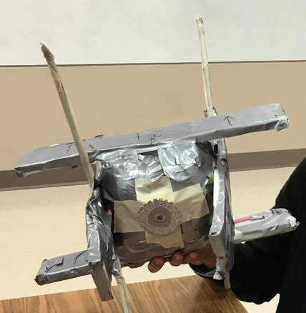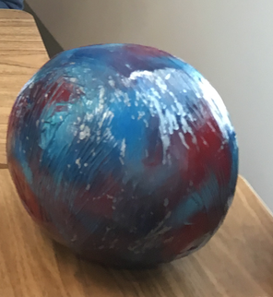

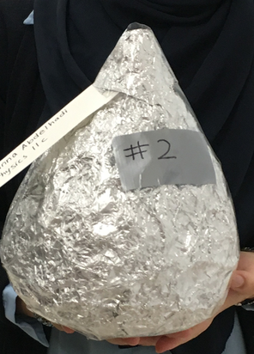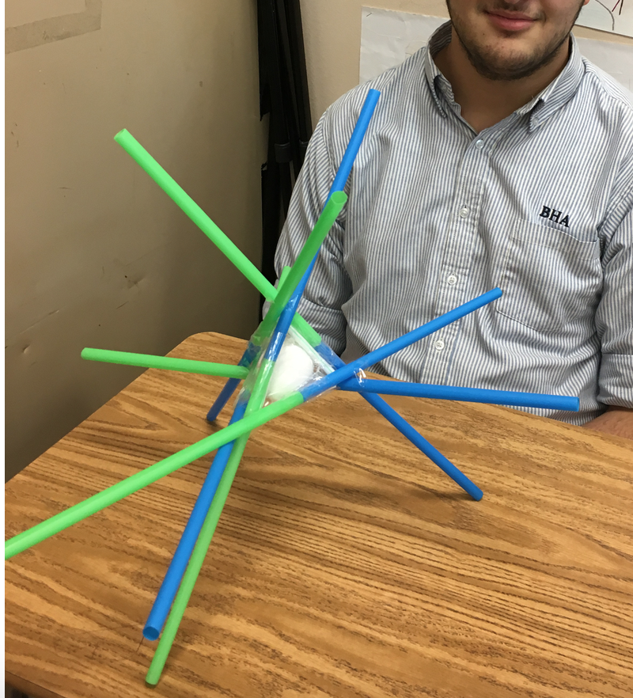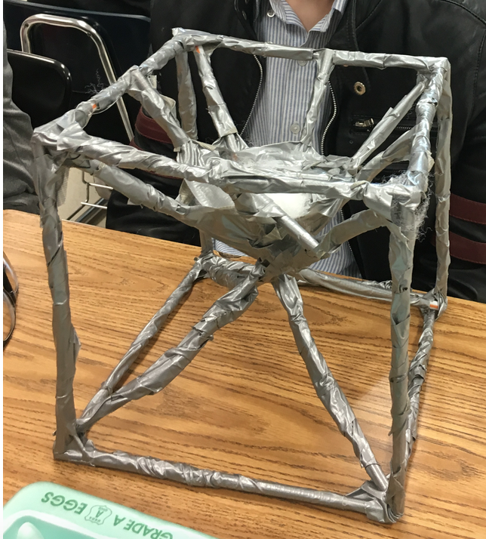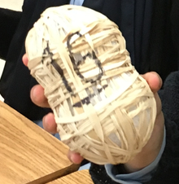

Making a musical instrument - Students demonstrate the knowledge of frequency and pitch of sound waves by making a musical instrument – stringed or pipe – and selling it to the audience

Inquiry! Inquiry!

Flashlights that don’t work – students figure out why they are not working and get them to work
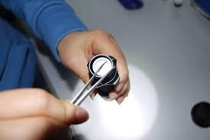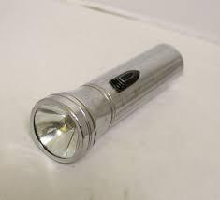

Toasters – How stuff works – Students take them apart and figure out how toasters work, they learn about circuits, motors, heating coil, temp control, etc.

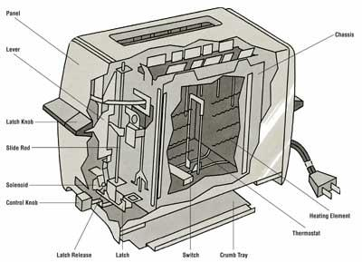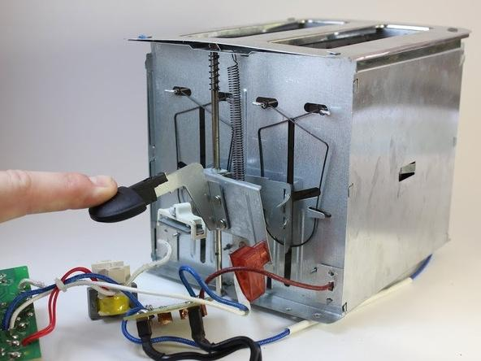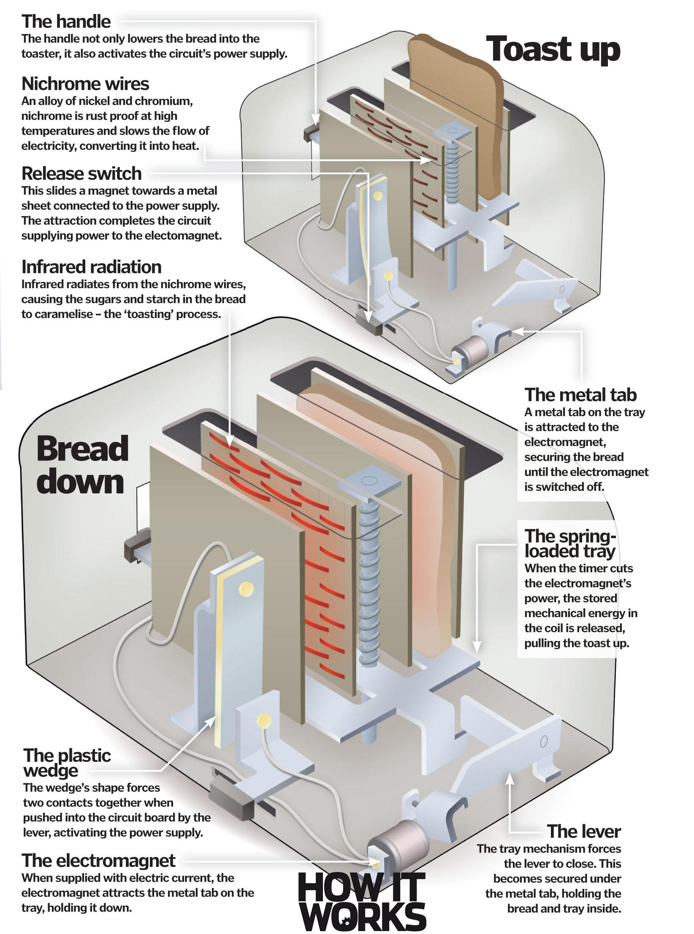

Hot wheels tracks – KE/PE, Conservation of energy

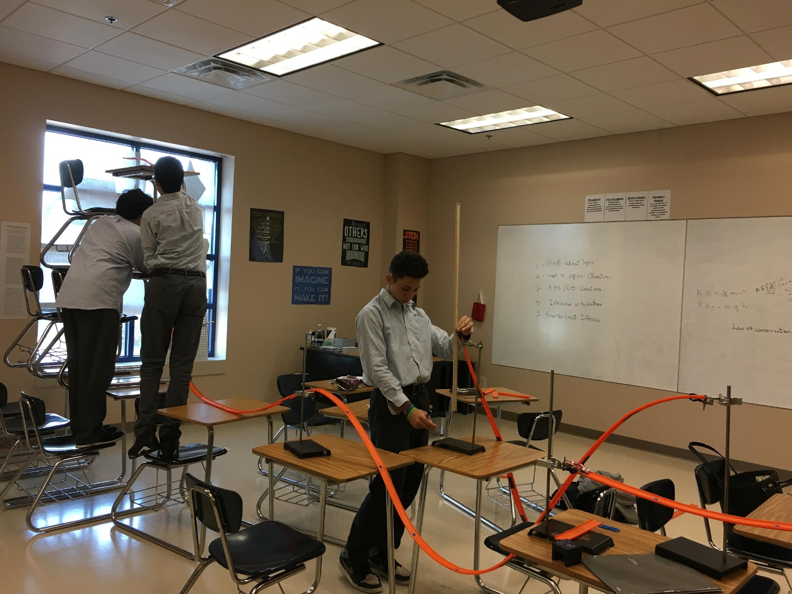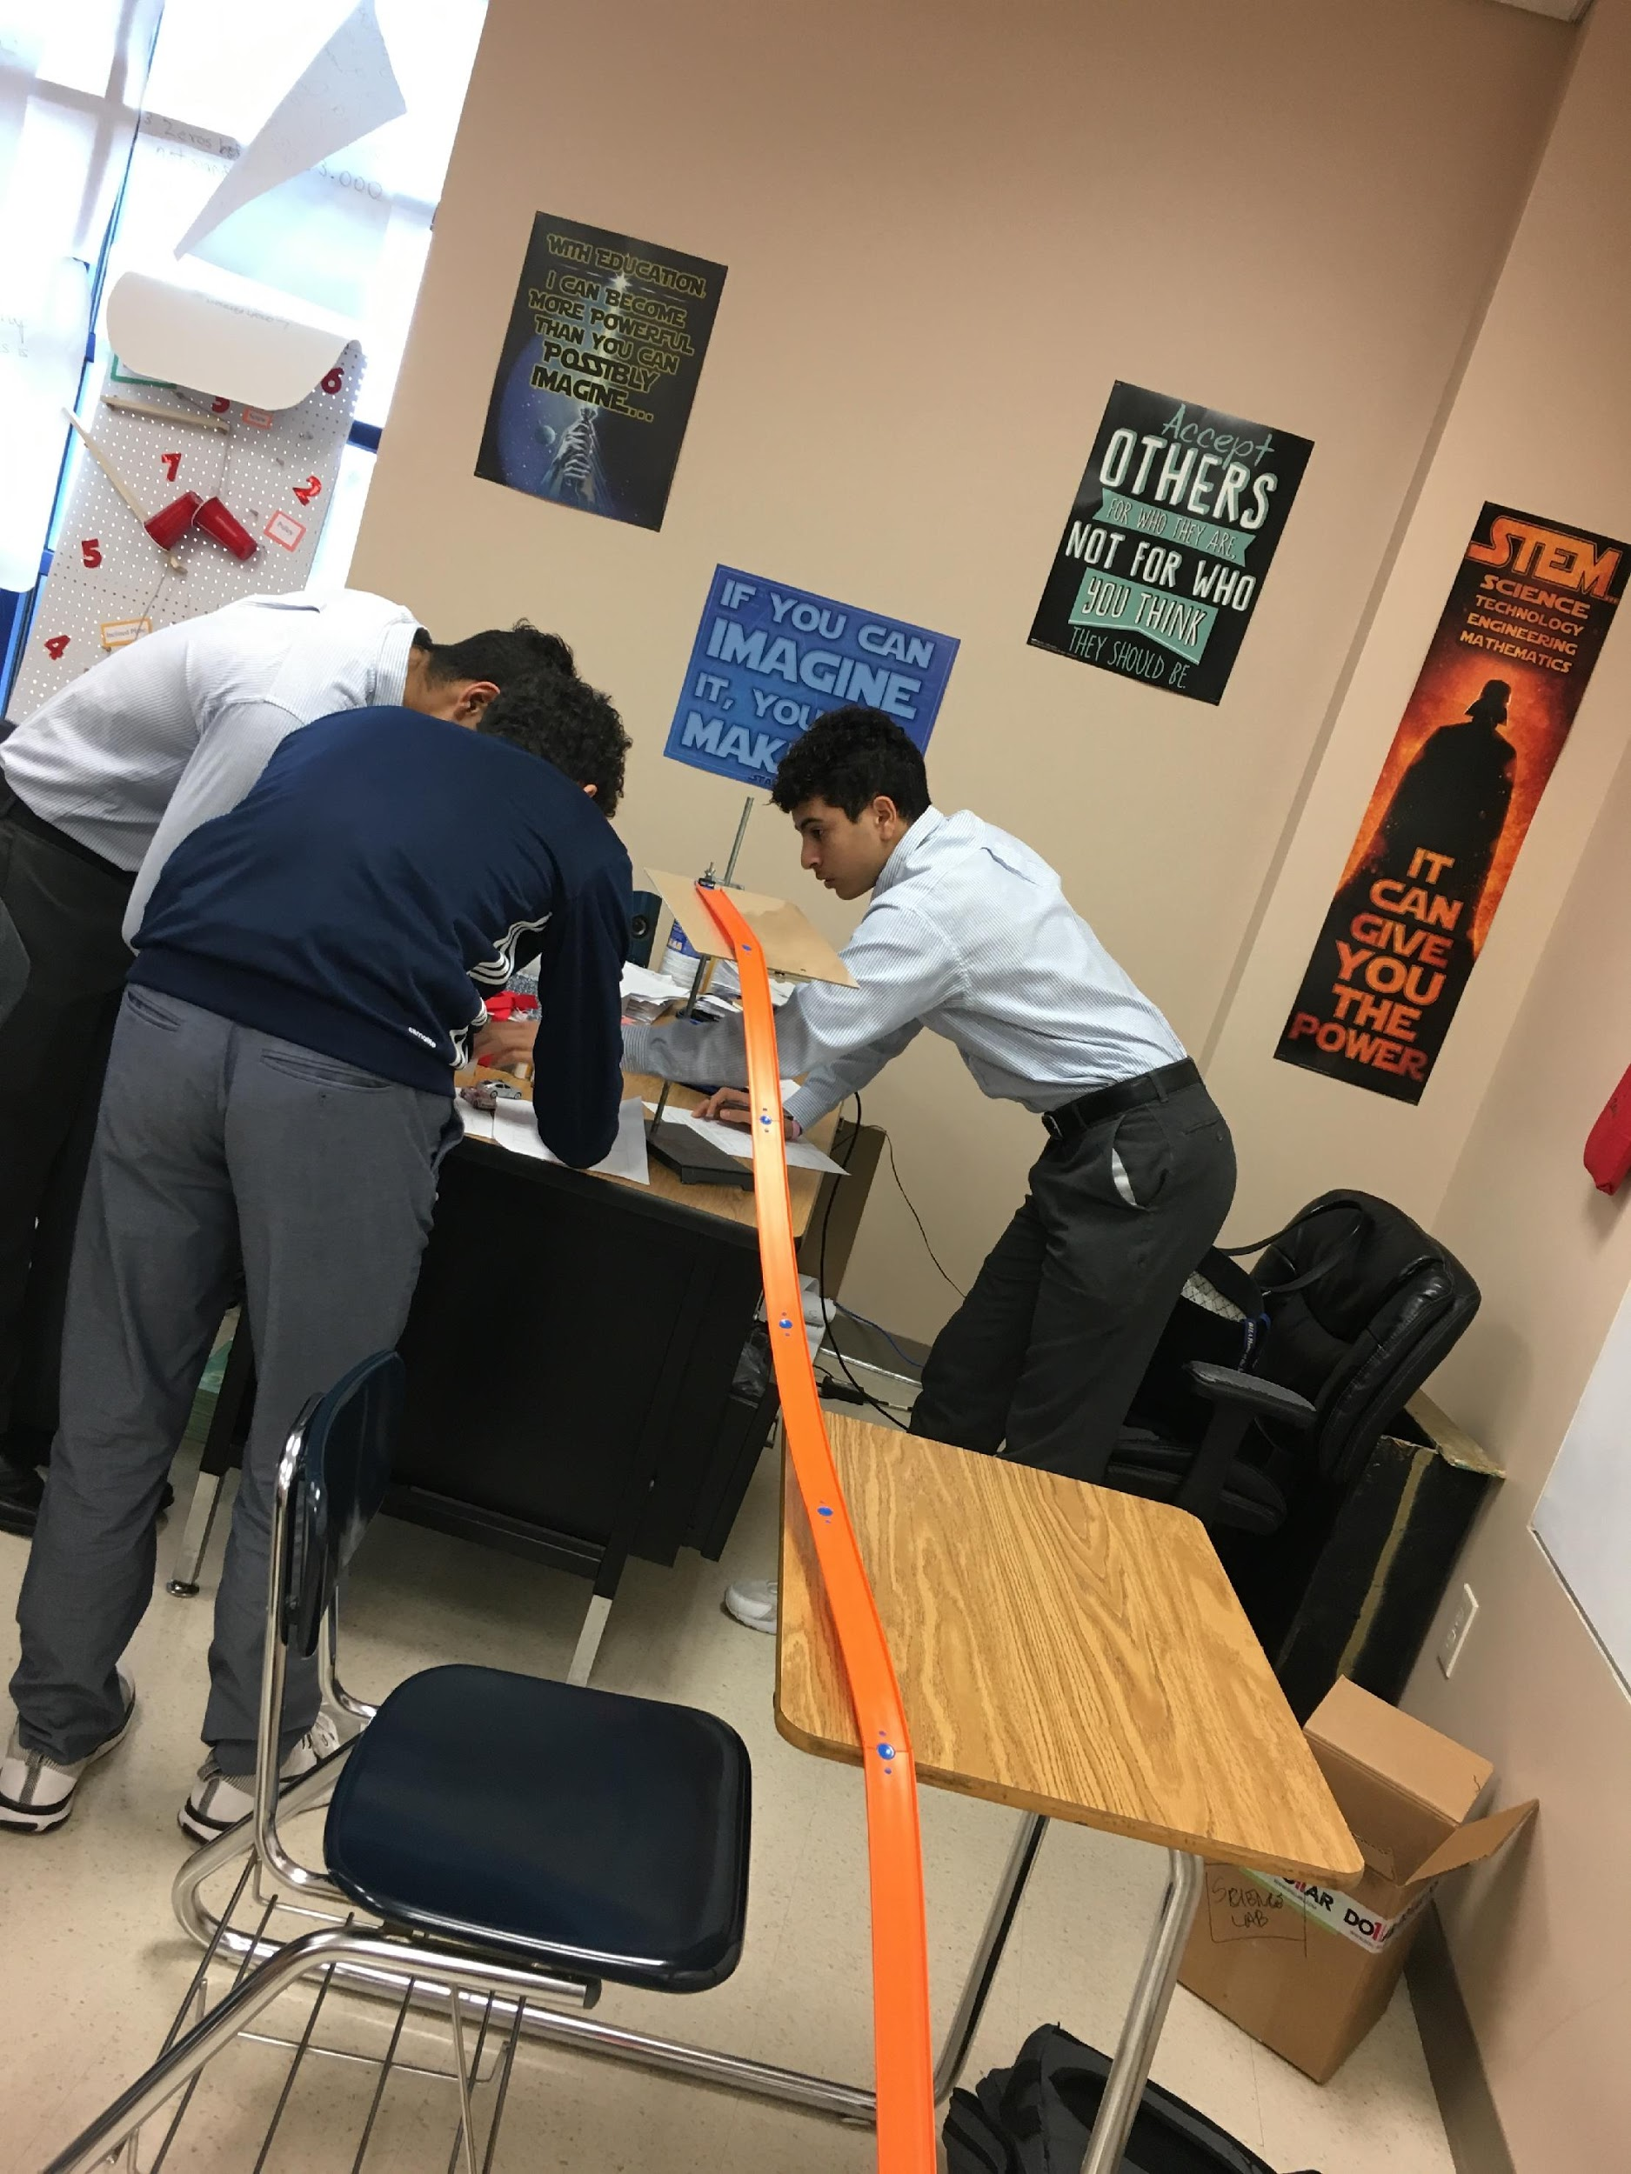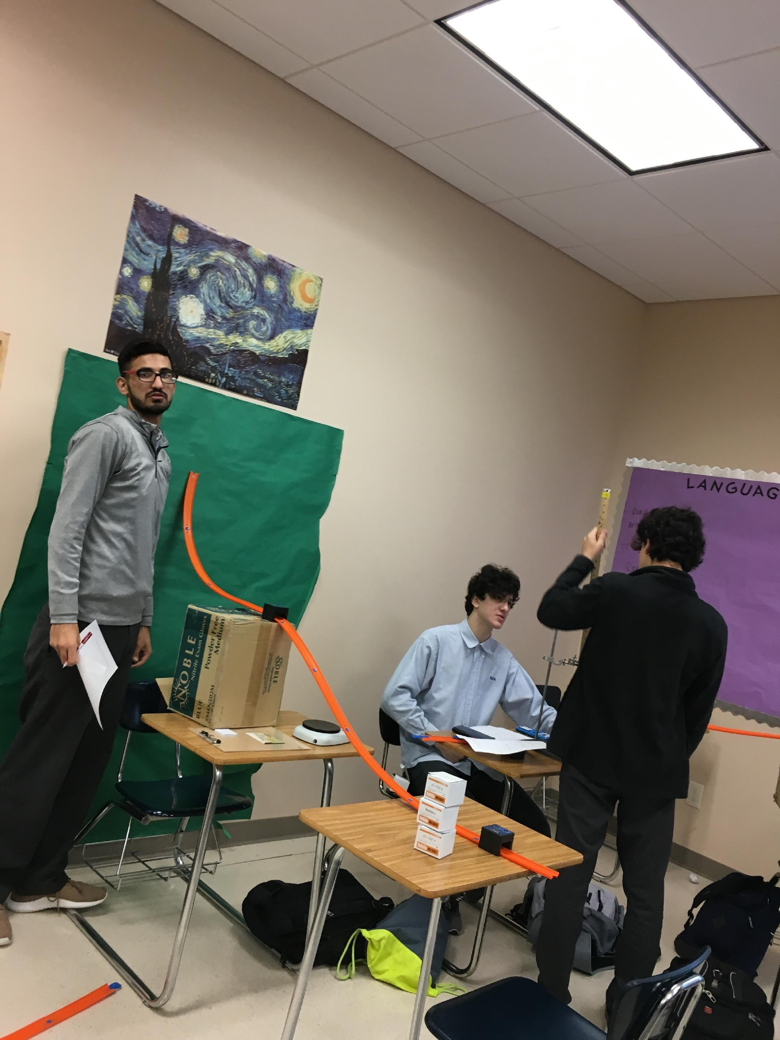

Projectile Motion
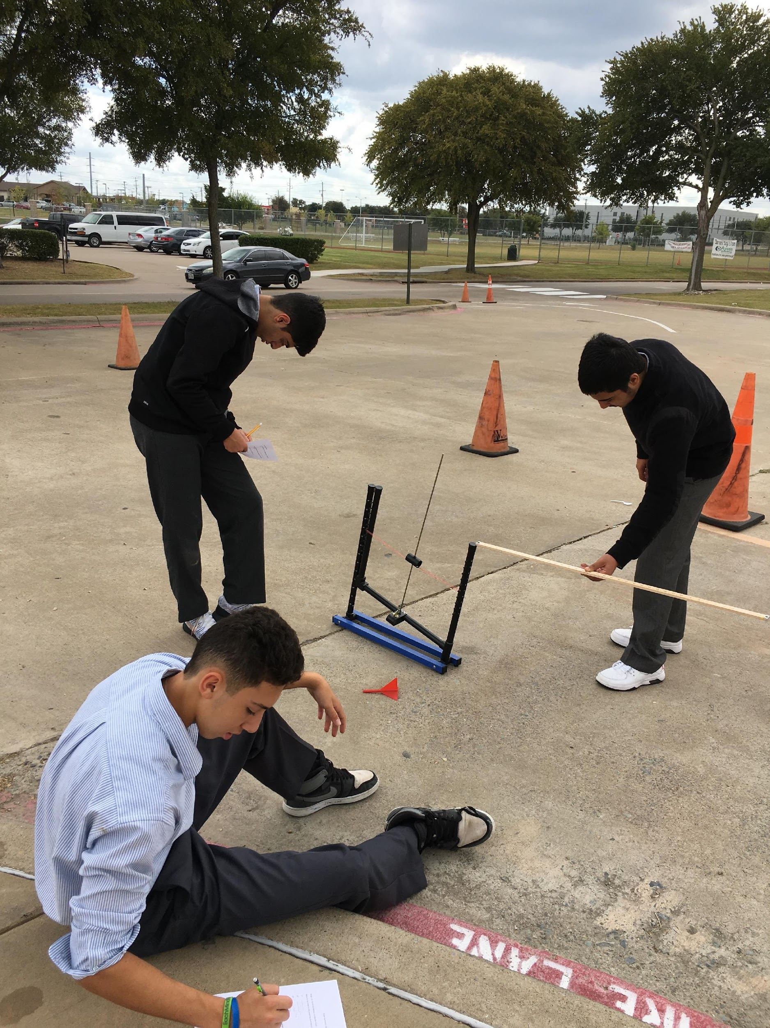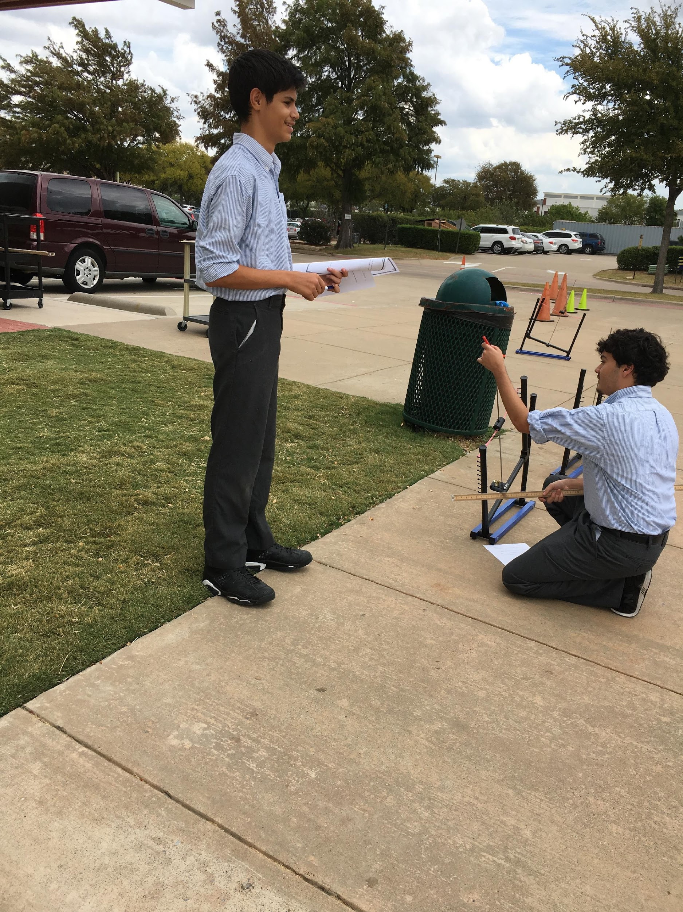

Games – Scienterrific games – Great for Hands on Reviews! Can do in groups/stations.
Can make your own, copy, laminate and cut!
Tatsulok – Newton’s laws, acceleration, balancing equations
Triconnect – Reptiles, amphibians, mammals
Don’t-cut-d-pillar – Scientific method, Heat
Board games – Properties of Matter

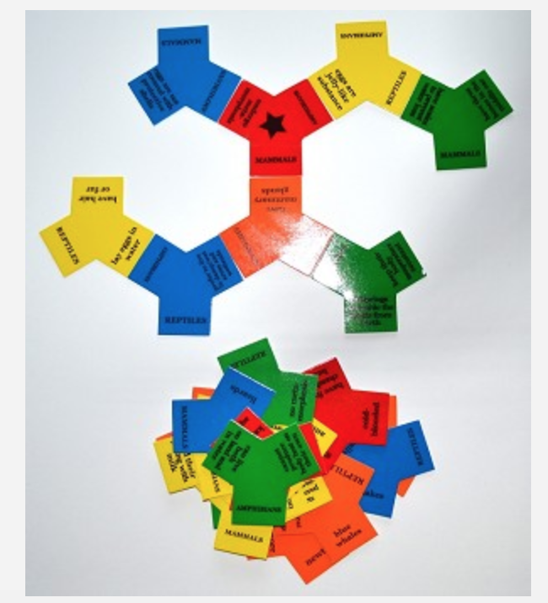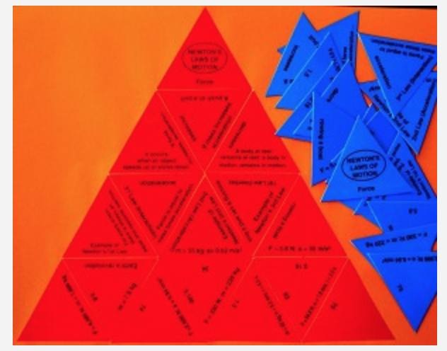

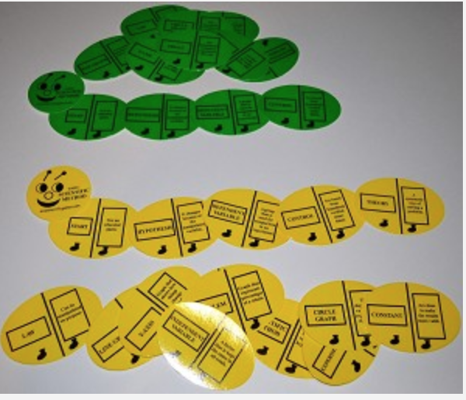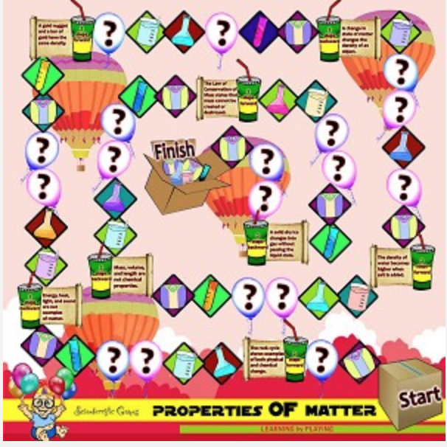

References
https://news.uchicago.edu/article/2015/04/29/learning-doing-helps-students-perform-better-science
http://www.scholastic.com/browse/article.jsp?id=3751901
https://ssec.si.edu/stemvisions-blog/what-inquiry-based-science
http://www.earlychildhoodnews.com/earlychildhood/article_view.aspx?ArticleID=409
Biography

Ms. Qamar Madani is a certified Texas Middle school and High school teacher. She holds a Bachelors degree in Biology from University of Illinois. She has been teaching for 10+ years at Brighter Horizon's Academy (BHA). She is currently the Science Department Head and leads a team of 5 teachers. She has taught grades 7th- 11th in her tenure with BHA. Ms. Madani is a proud mother of 6 children, with two of them graduating from BHA and currently holding Alumni status.

