No, Please Don't Leave! Nurturing & Sustaining Your Teachers

Paper presented at the 19th Annual ISNA Education Forum, March 30 – April 1, 2018 at the Westin O’Hare hotel in Rosemont, IL.

Author & Presenter: Dr. Yasmeen Qadri
Founder & CEO, EdConsultations,
Tenured Professor, Teacher Education Program &
Board Advisory Member, Peace & Justice Institute
Valencia College, Orlando, Florida

Editor: Dr. Omer Kazmi, Consultant, EdConsultations
Associate Professor, Valencia College & University of Central Florida
Orlando, Florida

www.edconsultations.com Orlando, Florida
yqadri@edconsultations.com

Abstract
Nurturing and sustaining your staff, especially your teachers, are top priorities for Islamic Schools. A quick turnover rate of teachers can result in a lack of confidence of the school’s success for parents, which would result in low student enrollment. This hilarious and interactive presentation is based on a book by Neila Connors titled If You Don't Feed the Teachers They Eat the Students. Connors’s guide leads to success for both administrators and teachers. The presenter, with three decades of experience as a teacher, principal, and board member, will share different ways to retain teachers. Principals and administrators will find this presentation valuable as they will learn different incentives that can help teachers become committed and take ownership of the school.
Keywords: Islamic schools, teacher retention, teacher development

No, Please Don't Leave! Nurturing & Sustaining Your Teachers
A good way to address the topic of teacher retention is to first review how a teacher develops. Teachers are not made overnight; it often takes years for teachers to master the techniques and skills to shine in their profession. Not knowing this beforehand can be fatal to novice teachers, who may believe they have to be perfect from the beginning. There are 4 Stages of Teacher Development as described in Sadker and Zittleman (2011) Teachers, Schools, and Society:
Stage I – Survival. At this stage, teachers worry about their survival in the class from just the basics of the profession, like their daily schedules, and they often wonder if teaching is the right job for them. Their list of concerns are: the challenges of classroom management, visits by supervisors, professional competence, and acceptance by colleagues.
Stage II – Consolidation. At this stage, the focus moves from the teacher’s survival to the children’s learning. The skills acquired during the first stage are consolidated and synthesized into strategies that are thoughtfully applied in the class. Teachers also synthesize their knowledge of students, and teachers in this stage are able to analyze learning and social or classroom management problems in the light of individual student differences and needs.
Stage III - Renewal. Once teaching skills have been mastered and an understanding of student development has formed—usually occurring after several years of teaching—predictable classroom routines can become comforting or boring. Teachers at this stage are ready to explore elsewhere or renew their commitment to their profession by attending conferences for professional development and net-working with successful colleagues.
Stage IV – Maturity. During the maturity stage, the teacher considers deeper and more abstract questions about education: educational philosophy, ways to strengthen the teaching profession, and ideas that can enhance education at the local, regional, national, and international levels. The maturity stage has nothing to do with the age of the teacher or the many years of teaching experience; unfortunately, some teachers may never reach the maturity stage, while others may reach it faster through their compassion and dedication to the teaching profession (Sadker & Zittleman 2011, p. 349).
Literature Review
The foundation of any successful school is highly competent teacher retention; yet in the United States, shortages in the area of teaching have been occurring across the country, reaching crisis proportions in some teaching fields like math, science and special education, and in locations where wages and living conditions are not attractive. (Podolsky, Kini, Bishop, & Darling-Hammond, 2016) Parochial and private schools often do not have high compensation for their employees, only adding to the difficulty of retaining teachers.
Teachers who leave the profession prematurely hurt student learning and cost schools a lot of money, not to mention adding a negative reputation to the school. Recruiting and retaining dedicated and passionate teachers are vital to the success of Islamic schools.
Solving the Teacher Shortage: How to Attract and Retain Excellent Educators (Podolski et al., 2011) shows that the “review of an extensive body of research on teacher recruitment and retention, [identified] five major factors… that influence teachers’ decisions to enter, stay in, or leave the teaching profession.” Three of the five Podolski et al. list apply very closely to Islamic School teachers: 1) salaries and other compensation. 2) induction and support for new teachers, and 3) working conditions, including school leadership, professional collaboration and shared decision-making, accountability systems, and resources for teaching and learning. (Podolski et al., 2011)
Discussion
There is great inequity in teacher salaries in Islamic schools when compared to public or even some private or other parochial schools. Islamic schools offer less compensation and little to no insurance or retirement benefits. In addition to the lack of funding for such benefits, there is sometimes a lack of support from the administration, school board, parents, or the community at large, which can impact the teacher’s decision to stay. Often, talented teachers leave the profession due to a lack of support programs, such as mentoring, coaching, and feedback from experienced teachers in the same subject or grade level as the novice teacher; this occurs primarily because Islamic schools are small and there may not be staff or faculty that can provide such advice or encouragement. Likewise, it is difficult to find opportunities for novice teachers to observe expert teachers; there are often no orientation sessions, retreats, and seminars for novice teachers; and Islamic schools do not provide reduced workloads or extra classroom assistance for these teachers. Teachers who do receive these types of support have been found to be more than twice as likely to stay in teaching when compared to teachers who lack this support.
Five factors, relating to working conditions, contribute to successful teacher retention of teachers in Islamic schools.
- Teachers who are knowledgeable about Islam and are deeply committed to serve in an Islamic institution.
- Teachers who believe in Islamic education and model that belief by putting their children in an Islamic school.
- School leadership and administrative support.
- Resources available for teaching and learning that include: sufficient instructional materials and supplies, safe and clean facilities, and reasonable student to teacher ratios.
- Opportunities for professional collaboration and shared decision-making.

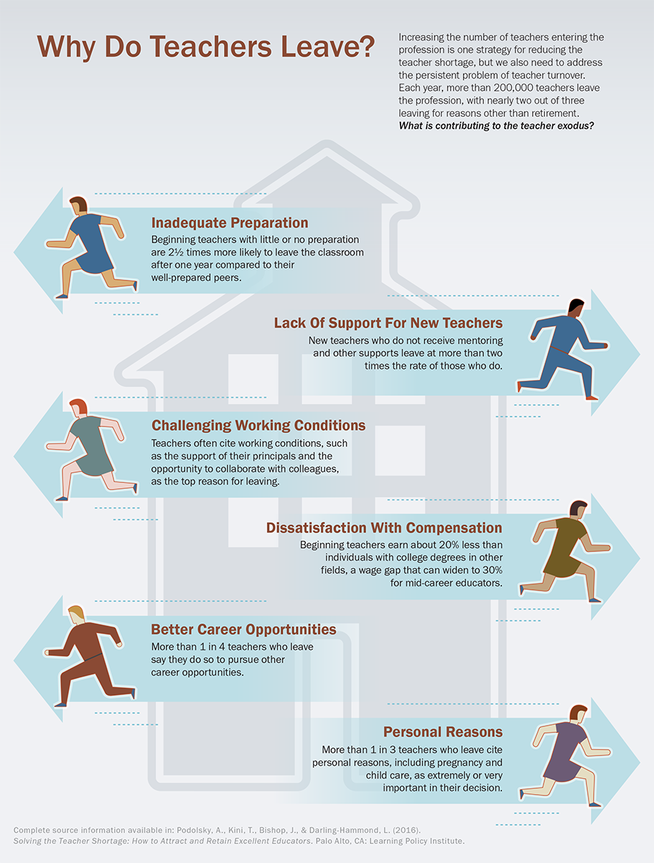
In Seven Habits Of Highly Effective Islamic School Teachers (Alam, 2014), the author recommends that Islamic Schools teachers “seek Allah in all that [they] do” and “share every inspiration with love.” While these are primary ingredients that form the backbone of all Islamic work, one must also consider how strong a driving force it can it be when not paired with proper resources. No matter how dedicated one is to Islam, a person still needs much support from the environment and co-workers; with that support, a teacher may be better equipped to seek Allah and share his or her inspiration with love.
There has been much written regarding teacher burn-out and survival skills in the classroom, but not much has been researched on the other important factors that influence teacher retention, whether in public or parochial schools. Based on three decades of experience and scholarly research, I have come to the realization that there are several additional factors that contribute to the successfully keeping teachers. Of course, first and foremost are the teachers themselves.
Teacher Characteristics. Teachers who are committed, passionate, and faithful in Islamic Education are more likely to continue their careers in Islamic schools. Teachers who consider their health; personal, emotional, spiritual, and professional development; and networking and mentoring can certainly survive longer than those who do not. But these qualities in the teacher are not the only reasons that would convince him or her to stay. The school itself can be the reason a teacher leaves.
Making Islamic Schools a Buffet. Islamic schools should not be designed as a one-size-fits-all experience; there will be a diverse body of students and teachers who have different backgrounds in education, ethnicities, and levels of understanding of the religion. Teachers who are young in age and are at the survival stage, which is the beginning of their career, may vary from those teachers who come to teach at the Islamic school in hopes of receiving discounted tuition for educating their children. Each age group has their own challenges: young teachers may leave the school once they receive teaching experience, and, while mature teachers may stay longer, they must consider their position in the school—especially if they have children at the school—will these mature teachers be discriminated against or will they be favored? Islamic schools should become like an “all you can eat” buffet so that each type of teacher can benefit from it. Professional development opportunities need to be provided, which would include attendance at educational conferences and any courses or training to enhance their careers. Teachers who have ambitions of promotion need to be given opportunities to serve as administrators or trained to be leaders and future principals. Funding needs to be provided from Islamic schools to pay for education enhancement so that their teachers can teach evenings at a college to help increase their income and stay current in their field. There should be contracts in place to retain these teachers for a period of at least two years so that teachers involved in the program would eventually benefit the Islamic school.
Principals as Master Chefs. Being an administrator in the twenty-first century, writes Connors (2000) in If You Don’t Feed the Teachers, They Eat the Students: Guide to Success for Administrators and Teachers, is not easy. It takes special people with particular gifts. Experienced educators value leaders who respect and recognize their effort, provide opportunities to make a difference, walk the talk of fairness, allow open and engaged discussions, and provide an honest and flexible work environment (Connors, 2000, p. 59).
Connors adopts the acronym CHEFS (Chief Heads Envisioning Future Success) to refer to principals whom educators value; she also describes them as exhibiting the following P’s: Positive attitudes, Pleasing personalities, Passion for their profession, Purpose, Patience, and Persistence. Some of the attributes that they demonstrate in schools are that they are People-oriented, Praising, Problem-solvers, Pressure-players, Performance-based, Proactive, Productive, and Parent- and Public-minded. Administrators who are fully committed to do whatever it takes to support staff, students, parents, and the community embark upon each day with a “go above and beyond” attitude. (Connors, 2000, p. 61). Conviction, Character, Consistency, and Connectedness are the driving forces in their leadership. Although these kind of administrators may not be commonly seen in most Islamic schools due to the stressful and demanding environment, there are a few that clearly and loudly show their strong senses of passion, purpose, mission, and vision for the school. These are the kinds of administrators who are able to provide unconditional support to their teachers, resulting in their retention and success.
Roles of Parents and Communities in Teacher Motivation. This factor can be represented with the acronym MEALS, or Meaningful Experiences Affecting Long-term Success (Connors, 2000). Most Islamic schools have few parents who are involved in their children’s education, but those involved parents are always the most dedicated and supportive of teachers by providing resources and working hard through bake sales and teacher appreciation days to show that Islamic school teachers are valued. Successful parent-teacher partnerships contribute greatly to teacher retention and success. Most parents are curious whether or not the teachers are doing a good job, or they come with the mindset that the more involved they are in their child’s classroom, the more it will benefit their child’s education. But there are some parents who go above and beyond without any selfish motives; they simply want to work collaboratively with the teachers, walking side-by-side to help them, encourage them, appreciate them, and support their hard work. They are not there to criticize or hold them at fault, but they are there to inspire them and appreciate them. They believe that an “ethos of caring and respect are vital; a caring school where parents demonstrate a characteristic of ‘with-it-ness,’ to do whatever it takes to build a dedicated staff.” (Connors, 2000). These few parents are the real heroes—the volunteers who tirelessly work to provide support not just to their child’s teachers, but all teachers at the school, as if they are providing “nourishing meals” so the teachers can survive longer!
Role of Board Members in Teacher Retention. Desserts when Stressed? While some do eat dessert when they get stressed out, the two words are related on a more grammatical level: their spelling. “Stressed” spelled backwards is “desserts,” and this palindrome is key in understanding what the school board does in relation to teacher retention. The ideal school board should reverse the mood of the teacher so that their stressed out attitude becomes sweet, like having many desserts. Efficient school boards do not attempt to manage the day-to-day affairs of the school, but work tirelessly behind the scenes in governance. These dedicated leaders know the importance of job satisfaction and what it takes to make teachers feel appreciated, respected, empowered, and valued. Although they are volunteers, their primary job is to bring in funds so that the teachers, administrators, and other faculty and staff can get paid. The board should take time to communicate, care, collaborate, and know when the teachers are stressed out, so they can serve them desserts. One way to reverse the stressed mood is to celebrate the work teachers do. Small celebrations can become recognitions for a teacher’s hard work, and that celebration could help build a positive relationship between the visionaries (boards) and the missionaries (teachers). Another way school board members can show involvement and appreciation for teachers is to organize discussion groups to look for solutions to challenges, implement a “Concerns Box” for the board, establish a “Take a Teacher to Lunch” day, put up a “Pat on the Back Bulletin Board,” set up a “School Board End of the Year Celebration,” raise the teacher’s salary, and provide other incentives. The school board can be a major player in retaining teachers if they simply took out some time from their busy schedules to show that their teachers matter.
Conclusion and Future Study
Teacher retention is a major problem throughout the United States, but it is particularly an issue at Islamic schools, which often are too small to have enough resources to adequately engage their employees. But given this, there are ways to solve this problem. The first is to properly understand the issue: why do teachers leave? This problem has already been discussed in various books and articles on the subject. The primary factors for teachers leaving their profession are: inadequate preparation, lack of support, better compensation, personal reasons, and challenging work environment. The lack of support, better compensation, and challenging work environment are the factors that are most directly connected with Islamic schools.
In order to alleviate these issues and keep teachers in the Islamic school, this paper offers various solutions. The first is to have qualified, religious individuals teach at Islamic schools. Islamic schools should prefer Muslim teachers over non-Muslim teachers as far as the law allows because the whole basis of the Islamic school is to preserve Islam in the student. Those who do not practice Islam may not see any benefit in staying because the connectedness to the community is not present. The teacher should also have qualities that would help keep them at the school: patience, understanding, caring. But choosing teachers that actually believe in the vision of the Islamic school, and would stand by that belief by enrolling their own children there, would be the strongest incentive for teacher retention. Therefore, having mature teachers with young children is ideal, and these teachers should be sought.
The teacher is not the only element in the process of keeping education consistent at the Islamic school: the school itself should be hospitable and open to keep teachers. The school, following the food-theme of Connor’s book, should be like a buffet where teachers of all different backgrounds would feel comfortable. There should be something for everyone at the Islamic school. This is fairly simple to implement, but it does take some research. Discovering the teacher’s personal situation and stage of teaching will help administrators know what they can offer the teacher as far as salary and professional development opportunities to keep the teacher there. Finding funding to continue their education to better prepare them—and establishing a contract so teachers do not simply leave the Islamic school after completing their advanced degree—would also help with retention. However, administrators who follow Connors’s P’s and C’s of education would be able to work with many teachers if such funding or opportunities cannot be found. If the teacher feels the support of the administration for him or her, he or she would be more likely to stay in the school. There should also be a sufficient disciplinary hierarchy to handle issues with students.
Parents and the community at large should also invest in the school. The investment should not be restricted to simply money, but also should include time and interest. Parents who are routinely involved in the school are not enough, if self-interest (that is, their children’s future) is all that is at stake. Altruistic parents who want to do what is best for the community and will take the time to appreciate and help all of the teachers at the school are vital in teacher retention. The community should produce such parents, and the larger community should respect and revere the Islamic school teacher. Often, reputation and respect can substitute a low salary. In fact, at the college level, more respected universities often get away with paying their faculty less because those faculty are willing to work there just to say they work at a prestigious school.
One of the more important factors in retaining teachers at the Islamic school is how the school board itself acts towards their teachers. While the board’s primary aim is to obtain funds for the school, it should do more when it comes to teachers. It should reverse their role in order to reverse a teacher’s mood, turning the stressed mood of the teacher to desserts. The board is able to do this by, to put it quite bluntly, acknowledging the teacher. Celebrating the teacher’s success, valuing their opinion by providing avenues for teachers to reach the board, and solving urgent issues are ways to show the teacher that there are means to alleviate the stresses of working at the school. Whether the teacher is in Stage 1 or Stage 4 of teaching, to know that there is support at the governing level of the school is crucial for the teacher to stay. A board that does not care about their teachers or is not the least bit involved in the general issues of the school risks enrollment, prestige, and—most importantly—risk the retention of good teachers!
So while it may seem that Islamic schools are in a dire state because of a lack of qualified teachers, there is hope. The implementation of the policies in this paper is cost effective in that it often does not require much money. The attitude is key here. If administrators, parents, and the school board altered the way they thought about the Islamic school teacher, if they all could acknowledge the hard work and stressful job of teaching at an Islamic school, then teachers would be more likely to stay. It comes down to whether the teacher has hope as well: if the teacher has hope—in advancement, improving the community, being respected—they would not want to leave the school. Rather, not only they would stay, but also they would blossom into Stage 4, mature teachers who want to help the community at large. They would become the role models of future generations, and these future generations would act as beacons of light in a dark world.

References
Alam, O. (2014). Seven Habits of Highly Effective Islamic School Teachers. Islamic Teacher
Education Program. Retrieved from http://islamicteachereducation.com/7-habits-highly-effective-islamic-school-teachers/
Connors, N. A. (2000). If You Don’t Feed the Teachers They Eat the Students!: Guide to Success
for Administrators and Teachers. Incentive Publications.
Podolsky, A., Kini, T., Bishop, J., & Darling-Hammond, L. (2016). Solving the Teacher
Shortage: How to Attract and Retain Excellent Educators (research brief). Palo Alto, CA:
Learning Policy Institute.
Sadker, D. M., Zittleman, K. (2011) Teachers, schools, and society: A brief introduction. New
York, NY: McGraw Hill.

