Islamic Schools Helping Develop the 3D Image of Our Youth: Dare to Dream with Dignity

(Paper presented at ISNA Education Forum by Dr. Yasmeen Qadri, March 30-April 1, 2018, Chicago)

Abstract: Sustaining Islamic Schools can be one of the most challenging tasks in the United States. With the increase in Islamophobia, sexual promiscuity, violence, and disrespect, it is becoming even more difficult to determine the success of Islamic Schools. It is a sad truth that Islamic Schools are not able to confront many teenage issues and are losing both girls and boys to the social ills of the society.

What can Islamic Schools do differently in an age of social media and technology to prepare our youth to hold onto the ideals of Islam, lead successful careers, and be in leadership roles?
This paper presents a motto that would help Islamic schools cope in these challenging times called “The 3-D Image: Dare to Dream with Dignity.”

This workshop will be valuable for teachers, administrators, and parents by preparing them to properly help our youth balance academic success, character development, and Islamic values to become leaders in western societies. The workshop focuses on teaching our teenagers how to:1) Dare (by instilling courage), 2) Dream (by aiming for the stars), and 3) hold on to their Dignity (without losing their Islamic identity and values).

New Developments and Challenges of Islamic School:
Nearly four decades ago, I was one of the founders of the first Islamic school in Orlando, the Muslim Academy of Central Florida. At that time, the Muslim community was debating if there was even a need for a full-time Islamic school and questioning its benefits. There were several close family friends who argued that Islamic schools would be more damaging than helpful to our children. There were times I personally was confused and would get aggravated with questions like: do we really need Islamic schools? I was undergoing teacher training in public schools, and I was struck by the prevalence of social ills and sexual promiscuity there—even as early as elementary school! I experienced culture shock of the severest form; I kept telling myself that Islamic schools are absolutely necessary if we want our children to Dare to Dream with Dignity.
Those were the days when, as new immigrants, we were in the survival stage, trying to struggle with new jobs, settling down as new families, and making sure the religious and cultural values were preserved for our next generation. During those years, working as a lead teacher and principal, I believed that the Muslim Academy of Central Florida was doing a marvelous job in spite of the challenges. We were worried that teachers would leave because of the low salaries and high stress, causing teacher burn-out. Our focus was on the daily survival of the school and making sure we were able to meet the basic expenses while dealing with everyday conflicts between ethnicities—things like differences of opinion on dress codes and zabiha meat.

As years went by, my children now have their own children, and my view has changed. I see the growth of the Muslim community, but at the same time I see my young children becoming adults, getting married, and having their own children. All three of my children, two boys and a girl, have turned out to be highly qualified professionals, MashAllah. They underwent almost arranged marriages, and now they are taking their children back to the very Islamic school I helped establish. They were not so happy with the Islamic school themselves, as it was not an ideal place. It was not, I’m sorry to say, free from prejudice, stereotypes, conflict, or envy. But they believe, like their parents did and do, that it was a place for character development and personality formation.

Like many of my friends and family, I believe that my children turned out pretty good professionals who achieved respectable careers and who value their faith. A friend once commented: “looks like your children’s Islamic school did a great job!” Honestly, it was not just the school. Like the old saying goes: “It takes a village to raise a child.” My children were blessed to grow up around both sets of grandparents, extended family, and friends who had similar cultural and Islamic values. My husband and I had made sacrifices, and we chose a path that allowed us to spend more time with our children rather than make money. We at least kept them under close supervision as both of us worked at the school our children attended. It was the school, the extended family, friends, and committed parents who raised our children and the children of the community. Our children were protected from both the physical and virtual worlds as social media and technology were just beginning to develop!
As we enter the late 2010’s, we see a paradigm shift surrounding Islamic schools. The debate is no longer whether we need Islamic Schools or not, nor is it about untrained teachers or a lack of curriculum standards. The important question now is how to define success, and how can it be measured and achieved. RAZI Education, a global consultant firm, (http://razieducation.com/) in the article, “Reframing Excellence in Islamic Schools: Elevating the Discourse,” describes their institutional aims based on the following overarching themes:
- Nurture a strong sense of Muslim identity.
- Teach Islamic values, history, and perspectives.
- Responsible citizenship and marketplace competitiveness guided by Islamic values.
Muslim identity is the most powerful of all, but also the most challenging of all, since now our identity is being lost or misunderstood. Many women, both young and old, begin to believe that their hijab is a barrier to their success and leadership. In an age of technological advancement, I believe that any limitation or dissatisfaction of the standards of curriculum can be controlled by substituting these skills virtually at home. Most parents criticize the lack of extracurricular activities at Islamic schools, activities like art and music. This too is not a challenge for parents as there are several YMCA’s and after school programs they can send their children to, like karate, swimming, baseball, basketball, volley ball, horseback riding, and others.
What parents really need to worry about is: are Islamic schools helping develop the 3 D image (Dare to Dream with Dignity) of our youth? It must be an image that is more than an identity, one of dignity!
Current political image of Muslims in North America: With Muslims continuing to be the focus of hatred and bigotry, Islamic schools must provide a sense of pride and self-esteem for being Muslim. Emma Green, in an article published in The Atlantic titled: “How Much Discrimination Do Muslims Face in America?” (July 26, 2017) (https://www.theatlantic.com/politics/archive/2017/07/american-muslims-trump/534879/), talks about the new data from the Pew Research Center: 75 percent of respondents said there is “a lot” of discrimination against Muslims in the U.S.; 60 percent of Muslims—and 68 percent of Muslim women—said media coverage of Muslims is unfair. And when respondents were asked about the most important problems facing U.S. Muslims today, the most popular answers included “discrimination, racism, [and] prejudice,” “Muslims [being] viewed as terrorists,” and “Trump’s attitudes [and] policies toward Muslims.”

Culture and language need to be nurtured at home and school; unfortunately many Muslims do not want to pass their cultural heritage to their future generations. They make sure their children are becoming “American” and their culture is no different than any American teenager! There has been much research to support the fact that when language is lost, culture is lost, and when culture is lost it may lead to losing one’s religious identity. What are Islamic schools doing to make their students loyal to their faith and ethnicity, but also to their country, as they learn about patriotism and civic education? Most people from Muslim countries are banned from entering the United States, and Muslim-majority countries are negatively stereotyped—all points that may detract from pride in our religion. It does not help when the children hear about terrorism or mistreatment of women in these countries. How many students can raise their head high in their own heritage and history? Other than an annual international fair, which deserves much appreciation, I am not sure if there is any form of awareness or curriculum transformation in Islamic schools to unite the Muslims as one ummah while each student maintains pride in their own heritage.

Impact of Social Media and Advancement in Technologies and Lost Parameters and Guidelines for Youth.
The other important aspect to maintain for a successful Islamic school is to preserve the students from the ills of the virtual society. Unlike when my children were in school and were under my care and protection, the parameters and boundaries have been lifted for today’s children through social media. “The Impact of Technology on Character Education,” by Tessa Jolls, President and CEO of the Center for Media Literacy, which was presented at the U.S. Department of Education Character Education Symposium in 2008, discussed the dilemma of technology and its impact on child development and character education:

Today, the global online village is open 24/7. Prior to this global village emerging, the local village provided children with a daily filter—adults—through whom youth learned about values, lifestyles and points of view. Today, adults are largely absent in the global village and technology filters are not enough. Because the education system is profoundly affected by new technologies, structural changes must be made to teach process skills as well as content knowledge to address the needs of the whole child. (Jolls, 2008)

Today’s children are far more advanced in the use of social media than their parents, and most schools are shifting from textbooks to laptops. Communication between parents and children, or between siblings and other family members, have been drastically reduced. Decades ago, this virtual global village was not as popular as it is today. It is a village where our children are connected—often to our surprise—very closely to strangers and to many others that may be influencing their character and behaviors. Parents and other adults used to provide a daily filter through which youth learned about differing values, lifestyles, and points of view. Today, through media and technology, the local is now global. The village has become so large that filters are no longer provided through human interaction but through technology itself (Walkosz, Jolls, & Sund, 2008). V-Chips, parental controls, and other software solutions provide these filters, but these technology filters are still not capable of delivering the discernment that human judgment can provide. The sheer volume of media interaction in the global village precludes much discussion with children about individual messages. (Jolls, 2008)

Youth currently spend an average of 8.33 hours per day (Rideout, Roberts, & Foehr, 2005)—more hours than a full-time working adult—engaging with technology-driven media. Douglas Rushkoff (2006) has called the younger generation “screenagers” because they so frequently interact with technology screens. But using such screens is not passive. Such activity now involves participation as part of a global participatory culture (Jenkins, 2006). This includes posting pictures, drawings, videos or text, discussing and circulating the postings, and mashing them into new creations. This also includes purchasing products and services. Prior to the emergence of this global village, the local village provided an environment in which everyone knew everyone else. Because the world is different now, parents and educators are concerned and see the need to assist the young in interpreting the messages they receive—whether perceived as positive or negative—and to understand their responsibility in producing messages in the global village.

Cyberbullying, cyberstalking, Facebook, WhatsApp, and videogame addiction can harm children and cause depression at worst, or it can merely waste their time on useless information at best. Our youth become consumers trapped by the billions of dollars spent on commercialization on the internet.

Social media is not only in our homes, but also it is creeping into most of our children’s bedrooms since it is contained in the palm of their hands and a click away. They are so dependent and interconnected to Facebook and WhatsApp that it may be easier to contact them via these sources than even talking to them face-to-face. At times, technology does not look like an asset, but rather makes us fear the harm done to children and sometimes by children: cyberbullying, cyberstalking, and videogame addiction are a few things that deeply affect a child’s psyche. When coupled with the notion that children under 12 also face an onslaught of media marketing designed to capitalize on their $30 billion in spending and their influence on more than $500 billion in purchases per year (Golin, 2006), the global village puts quite a decision-making burden on very young shoulders. More serious is the fact that media is influenced by values, lifestyles, and points of view from throughout the globe. Girls and boys not only learn about the diverse fashions and clothing from other cultures, but also can easily purchase them online. Dating, late night chats, exchange of pictures (most times beyond the parameters of haya’ and modesty) have become a common norm for Islamic school students.

Parents as Partners in Education in Helping Build Young Adults’ 3-D Image
So the challenge of today’s Islamic schools is to provide a 3-D Image: Dare to Dream with Dignity and this can be accomplished by making Parents as Partners in Education and by this I mean not just involving parents in bake sales and field trips or volunteering in lunch rooms or libraries; but to include them into building a learning community. What is being taught in the Islamic Schools must be reinforced at home by parents. Our children may have dreams and aspirations of becoming medical doctors, lawyers, business men or politicians… the opportunities are endless. These goals have always been the goals of the Muslim immigrants who themselves have been hard-working professionals. The difference now is to make these future professionals be proud of their Muslim identity and character education. With the rapid advancement in technology and surplus amount of information on our finger tips, the challenge is to help our youth learn to sort out fake news from real news, know the difference between fantasy and reality. Islamic education must be taught not through rote memorization but through the use of multimedia that “allows for accessing, analyzing, evaluating, creating and participating with multi-media messages. And finally, children need a sound value base to evaluate information, choices and decisions while weighing risks and rewards.” (Jolls, 2008) The negative images that are bombarded in the media are dangerous for the dignity of children. Perception leads to believing and believing leads to acting that may eventually be leading to self hatred of ones own faith and culture.

Thus our girls and boys are empowered youth on the media and it is the Islamic schools’ and parents’ responsibility to teach them how to swim through the ocean of information without sinking or being engulfed by waves and the dangers of the ocean.

Gender Preference in Islamic Schools: Most parents, when enrolling their children into Islamic schools, are more concerned about their daughters than their sons. As much as Islamic education is important to both genders, I would like to focus on the education of girls. The old saying that “the hand that rocks the cradle rules the world,” is even valuable today! Educating our girls to make choices on social media: the forbidden roads, whom to befriend, how much to expose of their personal lives, and what pictures to post or not to post are all important lessons that will help them maintain their dignity. Our young girls are encouraged to be lawyers, doctors, nurses, educators, fashion designers, and even stay-at-home moms! Whatever their choices, they must lead a life of dignity and respect. How can the Islamic school engrave these values in a virtually global village and provide character education?

Most students function well enough going through Islamic schools and living at home, but, once they leave the four walls of primary education and are out in the real world, they can easily lose their dignity. If we want to see them flourish as successful Muslimahs—dressed modestly with haya’ in character as well—who refrain from dating and become the leaders in their careers and communities, then we must help them fulfill their dreams. In a society where more than 50% of fame and success in the work place requires socialization and free mixing with the opposite gender, our girls must be trained well to carry themselves with dignity. They can be in leadership positions and learn public speaking while at the same time being proud of their heritage, culture, faith, and language and hold on to their courage to dare to dream big!

Dare to Dream with Dignity must be provided by Islamic schools nurturing the values of Islam. Today’s girls will be tomorrow’s wives and mothers, and what we give to them today will be theirs tomorrow. We need to provide them the Islam that is not merely rituals, but the Islam that is a way of life. We must teach them the skills to be compassionate, peace-loving, and charitable to the community as much as they can. They need to master the skills of conflict transformation, they must know how to get along with people they dislike, and they should participate in debates and national contests—this way they would have the courage to lead. “Such process skills, grounded in values and character, will enable youth to benefit from technology, to manage the risks they encounter, and to make responsible choices on a lifelong basis. Children need to be formally taught these process skills, which facilitate knowledge acquisition, problem solving and citizenship.” (Jolls, 2008)

It is easy for girls and women to say that their hijab is becoming a hindrance to their success when they are not given the 3-D Image. They can get lost in drugs and sexual promiscuity because of the misunderstanding of the main objectives of an Islamic school. It is imparting Islamic knowledge, but also empowering women to be the change that we as a Muslim ummah wish to see. Our girls must proudly connect themselves to the four great role models in Islam: Khadijah, Fatima, Aasiya, and Maryam.

Norma Carr Ruffino, in her book The Promotable Woman: 10 Essential Skills for the New Millennium supports my 3-D Image: Dare to Dream with Dignity! Using her advice as a template, we can empower our young girls to be:
- People-focused in a high-tech world.
- Credible and powerful in new corporate cultures (Dignity)
- Able to network across the gender gap (with modesty and haya)
- Able to create their own success (Dare to Dream)
- Able to negotiate win-win results (Conflict transformation)
- Able to manage multiple priorities (balance education, career, and family without compromising faith)
- Able to manage stress (and time)
- Able to channel their emotional power (take charge of their nafs)
- Able to communicate assertively to empower themselves.
- Able to manage difficult people situations

A well-rounded education is inclusive of extra- curricular activities, public speaking, self-esteem, global citizenship, leadership skills, conflict transformation, and of course excellence in academics. Parents as partners in Islamic schools must strive to provide a well- balanced and a well-rounded education to our youth where their talents and passions are nurtured and molded by Islamic values and behavior. These are going to be the future leaders and government officials and may have to be courageous enough to gently and (sometimes aggressively) push their way to the front and lead the future generations, In shaa Allah.

Let us help our youth develop their 3 D Image: Dare to Dream with Dignity. Here is a beautiful poem on Dignity that I hope you enjoy!
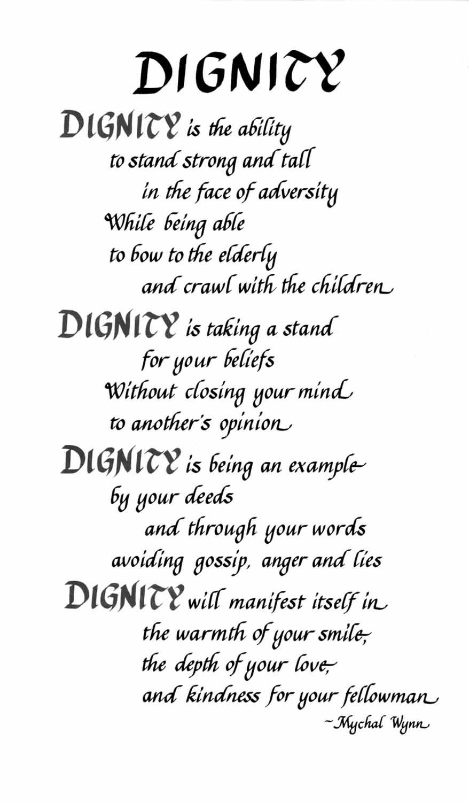

References

Carr-Ruffino, Norma. (1997). The promotable woman: 10 essential skills for the
new millennium. Franklin-Lakes, NJ: National Press Publications.
Green, Emma. (2017). How much discrimination do Muslims face in America?.
The Atlantic. Retrieved from https://www.theatlantic.com/politics/archive/2017/07/american-muslims-trump/534879/
Jolls, Tessa. (2008). The impact of technology on character education. Retrieved
from www.medialit.com
Qadri, Yasmeen. (2000). Our children, our future: An awakening call in the new
millennium. Hyderabad, India: Islamic Medicine Conference.
Razi Education. (2018). Reframing excellence in Islamic schools: Elevating the
discourse. Retrieved from http://razieducation.com/

