FROM GOOD TO GREAT: A PRACTICAL GUIDE FOR SCHOOL TRANSFORMATION

Noha Abdel-Hady

January 2018

ABSTRACT
Academic excellence is achieved by creating a school environment and culture that promotes the ideal Islamic identity that we strive to create in our students. Islamic schools struggle to find that perfect balance between academic excellence and Islamic education. There are many reasons behind such a phenomenon. This paper will explore some of the common struggles faced by Islamic schools. This paper also aims to address the key components needed to move Islamic schools from “Good to Great” as well as provide some practical ideas for Islamic school leaders. This paper is based on a comprehensive review of the literature found on Islamic Education in North America as well as the author’s own experience in leading and transforming an Islamic school in North America.
PROBLEM STATEMENT
Islamic education for Muslim children is a major problem facing the majority of Muslim families in America. This problem is due to a number of factors, some of which are: the lack of an Islamic school in many cities, lack of a sufficient number of students to warrant an opening of a full time Islamic school, parents’ inability to fund their children’s private education in an Islamic school, the low rank of many Islamic schools due to the schools’ inability to compete in the market with public schools that pay much higher salaries to their employees, and the perception within many Muslim communities that public schools will provide a better education that will lead to a higher chance to college acceptance.
Reality is, as Muslims, we need to build and sustain more successful Islamic schools across the nation. As school leaders, community leaders, and board members, we must learn the art of school transformation as it pertains to Islamic schools. How to use our current resources to transform our schools and move them from “good to great” is the question that we must answer in order to start moving the bar for Islamic schools.
LITERATURE REVIEW
The growth of Islamic schools in the USA has been significant over the past few decades. Muslim communities in the United States and Canada have placed a major emphasis on establishing alternative schools for their children (Haddad, Senzai, and Smith 2009; Merry 2005; Zine 2008). The pioneers of creating religiously affiliated schools are both the Christian denominations and Jewish communities (Fraser 1999; Nord 1995). According to Memon (2010), there are varied indigenous and immigrant communities that have sought to define what it means to be an American Muslim through Islamic schools.
Educational institutions along with mosques have served as a way of transmission of religious knowledge and practices, cultural history and identity, and transmission of both a moral and ethical code (Memon 2010). Mosques and schools have been initiated since the earliest Muslim Communities were established in North America (Haddad, Senzai, and Smith 2009; Nimer 2002). There are a number of different school types; however, for the purpose of this paper, we will focus on full time Islamic schools.
Full time Islamic schools aim to nurture a sense of faith consciousness through basic beliefs, practices, and an Islamic worldview that is embedded in the secondary and primary curriculum. The first push for Islamic schools in North America came through the Nation of Islam in the 1930s (Memon 2010). By the 1970s the Nation of Islam had established a group of schools, which were realigned with mainstream Islamic beliefs. A number of immigrant communities in the late 1970s started creating more Islamic schools to meet their growing needs.
According to Memon (2010), “Schools have grown exponentially with major spikes of growth during the mid 1990s and post 9/11.” Today, there are close to 300 Islamic day schools in North America, approximately 252 schools in the United States. There is still a substantial demand for both all day Islamic schools and weekend Islamic schools (Keyworth 2009; Memon 2009).
As suggested by much of the research done on Islamic schools, the need for more Islamic schools still exist and the need to improve our existing schools is even greater. With approximately 252 Islamic schools in the USA, there still does not exist one teacher education program that is geared towards preparing teachers to become effective Islamic school teachers in terms of the knowledge and the skills needed to be able to integrate the core curriculum with the Islamic teachings and practices. There still also does not exist a program specifically designed to prepare Islamic school leaders.
Since these programs do not exist as of yet, I propose looking at effective school improvement strategies that work for low performing public schools along with effective transformational leadership frameworks in order to extract the best strategies that fits our Islamic schools. This paper will suggest a practical guide to move Islamic schools from “Good to Great” based on a number of effective leadership and instructional frameworks that were used by the author to improve her Islamic school.
Some of the components discussed in this paper will reference the High Poverty High Performance Framework (HPHP) by Mass Insight. Mass Insight Education and Research Institution has developed this framework that encompasses a number of approaches and characteristics that brings highly challenged student population to high achievement. According to Mass Insight, there are nine factors that are common and contribute to the success of urban schools. These factors “enables the schools to acknowledge and foster students’ Readiness to Learn, enhance and focus staff’s Readiness to Teach, and expand teachers’ and administrators’ Readiness to Act in dramatically different ways than more traditional schools” (Calkins, 2007). These above mentioned three main components (readiness to learn, readiness to teach and readiness to act) create the backbone of the HPHP framework.
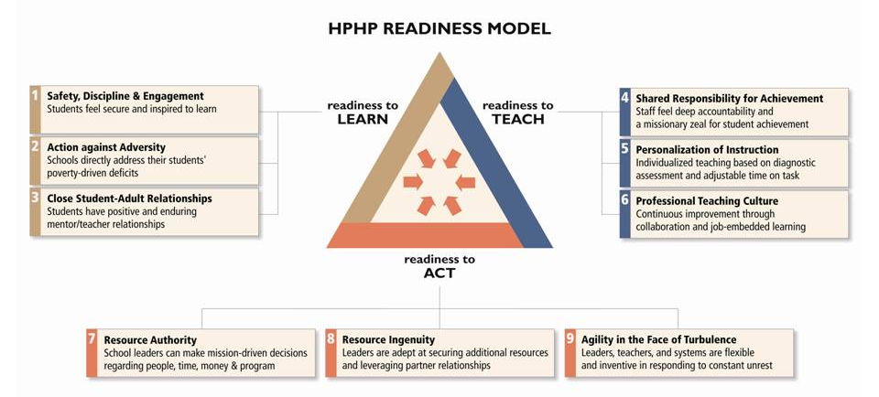
TALENT MANAGEMENT
Recruiting, hiring, training and retaining highly qualified teachers is one of the most important aspects of a school’s success. Without creative and effective teachers, there is so little that school administrators can do. As discussed above, there still does not exists one teacher-training program for Islamic school teachers in the USA. Thus, school administrators must be ready to hire the most coachable teachers available and invest heavily in training them. It is hard to change one’s belief, but if you can change and influence their action and their behaviors, their belief will eventually follow. This is very important to keep in mind when school leaders inherit teachers that do not believe in the vision of the school leader. The following are, from experience, the most important look for when hiring an Islamic school teacher: (In no particular order)
- Teachers with strong content knowledge.
- Teachers that are interested in taking leadership roles as teachers.
- Teachers that are creative, energetic and most importantly have PASSION for the work and for the students.
- Teachers that have a strong Islamic knowledge base and are willing to accept the school’s Islamic philosophy and deliver it to the students through their curriculum.
- Teachers that have excellent communication and interpersonal skills.
Throughout my years of experience as an Islamic school leader, a public school leader and as a private consultant, I have found that teachers who posses these above-mentioned qualities can be trained and coached to become highly effective teachers. As all Islamic school leaders know, it is very hard to compete for teachers with the public school districts in terms of salaries and benefits. So finding certified and experienced teachers have always been a struggle. When those teachers are not available, it is important to know as a leader that the pedagogy is teachable, but passion, enthusiasm, love for children and interpersonal skills are not skills that can be easily taught. For example, when looking to hire a math teacher and a certified teacher can not be found, finding an engineer who is looking to change careers to teaching, but has not yet become certified, is a smart move; if and only if that person is: coachable, possess the above-mentioned qualities, and is open to feedback. Then only, this engineer with proper support and professional development can become an amazing Math teacher.
It is crucial for board members to know the importance of hiring talented and effective teachers for the school to succeed. When budgeting, it is important to note that the best return on a school’s money is money spent on teachers and for teachers’ development. When resources are scarce, and salaries cannot be increased to match public schools, we must think outside the box to find ways of showing appreciation to our teachers. Comp time, free/reduced cost on site daycare, tuition discount for children, flexibility of scheduling, support in certification courses or exams, etc. are all examples of some creative ways that Islamic school principals can use to make their teaching positions appealing to teachers.
SCHOOL IMPROVEMENT PLANNING
Based on research done by Hanover Research Group that looked at a number of school improvement planning models, the following were the major key findings:
- Effective school improvement planning models emphasize comprehensive needs assessments, strategic prioritization of needs, and data-driven decision-making.
- Schools should initiate school improvement planning with a comprehensive needs assessment to systematically determine high-need areas.
- School boards should organize school-level task forces to design, implement, and track improvement efforts.
- Following a comprehensive needs assessment; school leaders must establish rigorous yet attainable goals.
- Schools should use four primary types of data to evaluate school improvement: student learning, demographics (enrollment numbers), school environment, and implementation fidelity.
- Throughout the school improvement process, school leaders should communicate objectives, progress, and results with all relevant stakeholders.

For Islamic schools to succeed, school improvement planning must be carefully done. School improvement planning is planning for the school’s continuous improvement over time in a systematic way. As Islamic school leaders, we tend, sometimes, to get caught in the everyday operations of the school and forget about the larger mission and goal. School improvement planning in Islamic schools must include members from all stakeholders. Board members, parents, students, teachers, school administrators and community leaders should all be actively involved in all stages of school improvement planning.
TRANSFORMATIONAL LEADERSHIP
Kirtman and Fullan (2016) have suggested seven leadership competencies needed in order for leaders to initiate and sustain change in their organizations. The seven competencies are:
- Challenge the status quo.
- Build trust through clear communication and expectations.
- Create a commonly owned plan for success.
- Focus on team over self.
- Have a high sense of urgency for change and sustainable results for student achievement.
- Have a commitment for continuous improvement for self and organization.
- Build external networks and partnerships.
It has been my own experience that change in general is frowned upon and more so in Islamic schools. When I started my tenure as the principal of my school and started challenging the status quo, I was faced with resistance and push backs from teachers, parents and even some board members. This is when I realized that I had to build a coalition and identify key players that would help me in transforming the school and in carrying the message to all stakeholders. I had to learn what Kirtman and Fullan (2016) recognized as the key to a leader’s success, which is the “ability to know when to push and pull (p. 15).” They continue on to say, “Knowing how to read the tea leaves when moving change forward and pulling back to ensure key people are on board are skills leaders can learn (p.15).” These are indeed all skills that are not only curial for the success of the leader in becoming transformational and moving his/her school, but also can be easily learned and developed with experience and time.
Finding a mentor or a coach is very important for any leader and especially for Islamic school leaders. I looked for a coach from within the community that the school was serving. It was beneficial for me as a new comer, not only to the school but also to the community, to have a mentor that has lived in the community for years and knew exactly who are the innovators, the change agents, the pragmatics, the skeptics, and the traditionalists (Change adaptation continuum). Being able to identify these people from the get go, allowed me to create an effective entry plan that was successful.
CONCLUSION
More and more Islamic schools are opening across the USA and the need for specialized teachers and leaders preparation programs for these schools is greater than ever. We cannot stand still until these programs are established; there is a wealth of knowledge and much research done on high poverty, high minority, and private schools that we can use to start initiating change in our own schools. As school leaders, we must take it upon ourselves to develop ourselves professionally and equip ourselves with all the tools needed in order to train our own teachers and transform our own schools.

References
Barbour, C., & Norton, N. (2014, October). Best Practices for School Improvement Planning [Scholarly project]. In Best Practices for School Improvement. Retrieved January, 2018, from http://www.hanoverresearch.com/media/Best-Practices-for-School-Improvement-Planning.pdf

Calkins, A., Guenther, W., Belfiore, G., &amp; Lash, D. (2007). The Turnaround Challenge. The Turnaround Challenge. Retrieved July 26, 2016, from http://www.massinsight.org/wpcontent/uploads/sites/2/2015/11/TheTurnaroundChallenge_MainReport.pdf

Fraser, James. 1999. Between church and state: Religion and public education in a multicultural America. New York: St. Martin’s Press.

Haddad, Y., F. Senzai, and J. Smith. 2009. Educating the Muslims of America. New York: Oxford University Press.

Keyworth, Karen. 2009. Islamic schools of America: Data-based profiles. In Educating the Muslims of America, ed. Y. Haddad, F. Senzai, and J. Smith, 21–38. New York: Oxford University Press.

Kirtman, L., & Fullan, M. (2016) Leadership: key competencies for whole-system change. Bloomington, IN: Solution Tree Press.

Memon, Nadeem. 2009. From protest to praxis: A history of Islamic schools in North America (Ph.D Diss., Ontario Institute for Studies in Education, University of Toronto).

Memon, Nadeem. 2010. What Islamic School Teachers Want: towards developing an Islamic teacher education programme. Toronto, Canada: British Journal of Religious Education, no. 33:285-298.

Merry, Michael. 2005. Advocacy and involvement: The role of parents in western Islamic schools. Religious Education 100, no. 4: 374–85.

Nord, Warren. 1995. Religion and American education: Rethinking a national dilemma. Chapel Hill, NC: University of North Carolina Press.

Zine, Jasmin. 2008. Canadian Islamic schools: Unraveling the politics of faith, gender, knowledge, and identity. Toronto: University of Toronto Press.

