Enriching Our Curriculum Through the Arts
A Practical Guide to Integrating Art in our Classrooms

Mona Abdala
Noor-Ul-Iman School

​ 18th Annual ISNA Education Forum
April 14-16, 2017

As an Islamic school teacher for fifteen years, I’ve tried many different approaches in an effort to be effective. There is no better class, student, or assignment than one that engages as many corners of the brain as possible. Creativity is the glue for the scientific, mathematical, and linguistic mind. They all work better when these sections of the mind are engaged and able to problem solve from different perspectives and angles. Art education is a missing link that we need more of, but seem to be getting less and less of. Visual arts, performance arts,
One year, in one of my favorite seventh grade classes, I taught an un-medicated ADHD student and struggled daily to manage the class. The experience left me distressed and at times in tears after school. One day, I was doing a pattern name project (see fig.1), and for about half an hour, I noticed that my student wasn’t making noises, talking, out of his seat, or otherwise being disruptive. He was focused intently on doing his project. I realized that this sort of work engages him in a way that his vocabulary drills, reading, writing, and grammar work, even in groups most certainly did not. I learned that for my students, art will provide a useful technique in order to find the mental clarity required to retain new information better. Additionally, it provides a good option as a task to work on during empty time. Usually when a student starts a project, he or she has the internal motivation and drive to want to finish it. According to years of research, arts education is closely linked to everything that we as parents and teachers strive to teach our students. Not only can art integration help yield easily calculable gains such as improved academic achievement and problem solving, it also is linked to improvement of connections between brain hemispheres, more positive social and emotional development, and foster a greater sense of teamwork and community involvement.
Unfortunately, in an effort to raise standardized test scores, with the advent of No Child Left Behind, the time given to any subjects other than reading and math class is reduced, including the arts. With tight budgets in public and private schools, and increasingly crammed curriculums with state-mandated core skills, the attention given to the arts is minimal and fast decreasing. Islamic schools are especially packed with extra classes. As educators, our goal is to find ways to integrate art into our regular curriculum while working within the reality that it may not receive any new funding or attention. Given that there are many factors working against art integration in our schools for various reasons, there are still many ways to integrate arts and give the students the tools they need in order to reap its benefits. There are a multitude of reasons to take this step in our classrooms.
ART IMPROVES MOTIVATION AND CONCENTRATION
Aside from being plain fun, the effects of art on the students can be immediate, as the act of partaking in an art activity may simulate a meditative state in which the mind is in the best condition in order to receive information. According to “Art and the Brain in the Learning Process” by Carneiro (2000), from cerebromente.org, the typical brain wave rhythm for alertness is beta, which isn’t optimal for data retention and mental clarity. When the brain waves move to alpha, where it is when experiencing mental relaxation, such as while working on an art project, we see that students are in a position to learn much better. Therefore, one can conclude that the best time for a few minutes of an art project would ideally be before explaining a new concept or asking the students to perform a task that requires high level thinking.
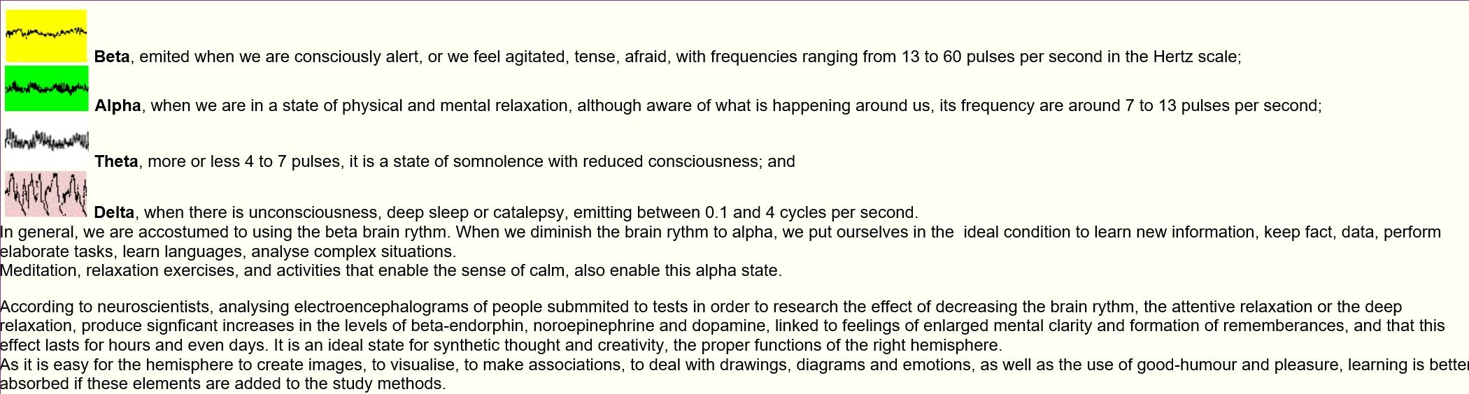
Music also will decrease the brain rhythm, silencing it to the wavelength that is optimal for learning. Some research suggests that baroque music, which has the same frequency that the fetus hears directs the information directly to the right side of the brain which is used for long term storage. See the following video for a good example of this type of music. https://www.bing.com/videos/search?q=baroque+largo+music&&view=detail&mid=7E1B037935392D3966CE7E1B037935392D3966CE&FORM=VRDGAR
ART IMPROVES TEST SCORES, IMPROVES ADADEMIC ACHIEVEMENT AND PROBLEM SOLVING
Studies show that integrating arts into the curriculum can help students perform better across the board. According to Henry, (2002), in a USA Today article, students that are exposed to various types of art actually perform better across subject areas. A report done in 2002 by the Arts Education Partnership analyzed 62 studies by about 100 researchers and compared the academic achievement and performance on standardized tests of students with students with and without art education.
“’School children exposed to drama, music and dance may do a better job at mastering reading, writing and math than those who focus solely on academics,’ says a report by the Arts Education Partnership.”
"Notions that the arts are frivolous add-ons to a serious curriculum couldn't be further from the truth," says James Catterall, education professor at the University of California-Los Angeles, who coordinated the research.” Henry (2002)
The students who have various categories of art included in their education not only scored better, but showed improvements in social skills and increased motivation. The correlation between art education and students performing better on a whole is clear and well-researched.
Even though the arts are the first departments to get cut in schools when budgets are tight, many school districts are still paying attention to the research on art education and implementing some interesting approaches to art instruction. In an Edutopia article, Vega (2012) says, that some of these approaches include using musical notes to teach fractions, writing and performing plays about historical events, playing classical music in the hallways such as well-known pieces by Mozart, and of course, the traditional visual arts classes. The schools that are following these trends are seeing much better results than the schools that are focused on the core subjects only.
"If they're worried about their test scores and want a way to get them higher, they need to give kids more arts, not less," says Tom Horne, Arizona's state superintendent of public instruction. "There's lots of evidence that kids immersed in the arts do better on their academic tests." Vega (2012)
One of the schools commonly studied is the Wiley H. Bates Middle School in Annapolis, Maryland, that won a 4-year grant to integrate art education. The improvement of performance and behavior was immense. “…the percentage of students achieving or surpassing standards for reading has grown from 73 percent in 2009 to 81 percent in 2012, and from 62 percent to 77 percent for math during the same period, while disciplinary problems decreased 23 percent from 2009 to 2011.” Even though the state average in reading and math have been increasing steadily in Maryland, the students’ improvement was 12 times faster than the average improvement in other schools across the state in reading, and four times faster in math. Vega (2012)
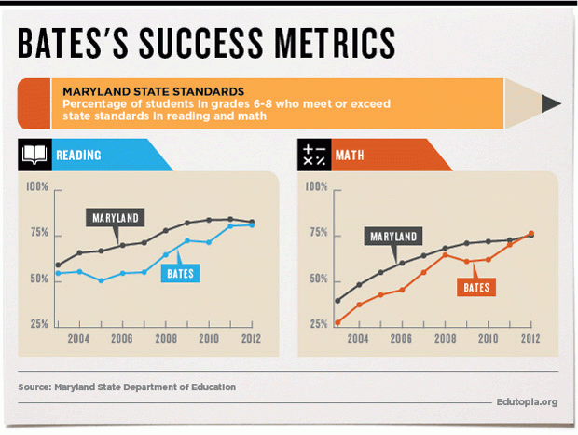
Vega (2012)
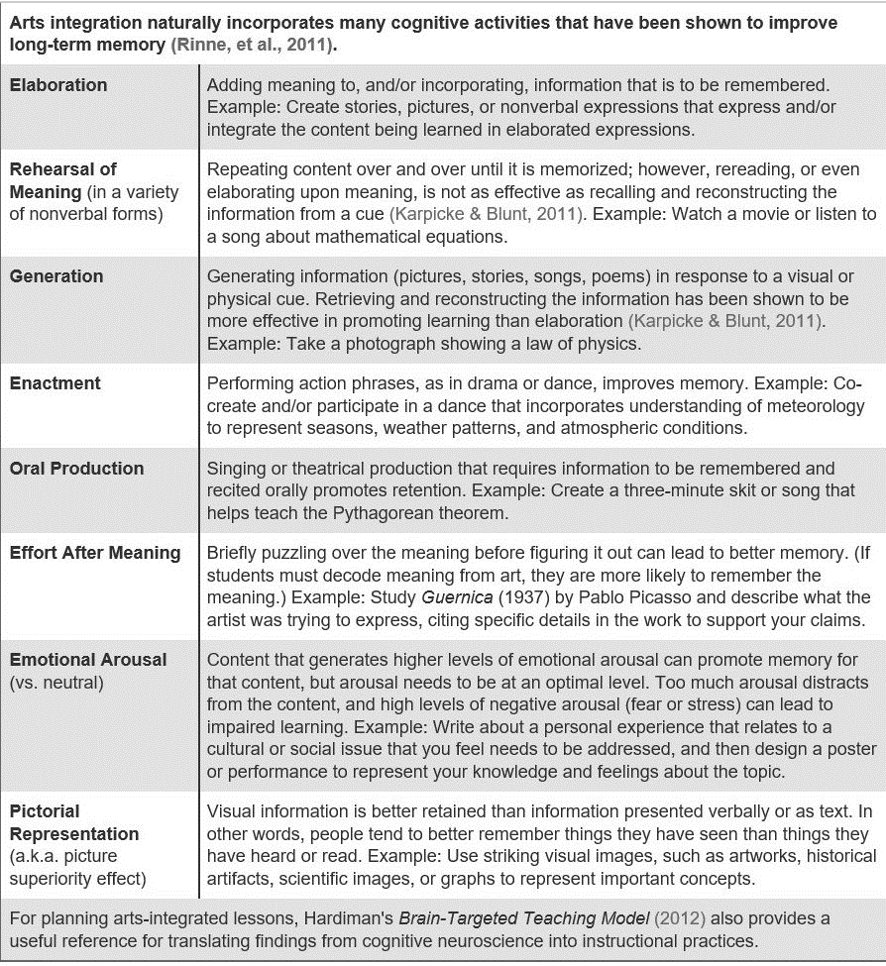
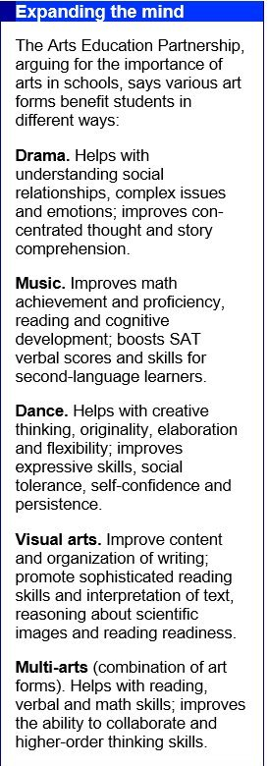
Furthermpore, according to Edutopia article, “Why Arts Education is Crucial, and Who’s Doing it Best,” there's ample evidence that kids immersed in the arts do better on their academic tests. Smith (2009). Study after study shows the strong connection between achievement on all levels for the student when the arts are incorporated. The chart below illustrates the ways that the different arts can help students. Drama improves social development and comprehension of stories, music helps students become more proficient in math, as well as verbal skills, dance helps with social skills as well as confidence and creativity, the visual arts improves writing, reading, and writing organization. When the mediums and art forms are combined, these improvements are magnified. Smith (2009).
ART IMPROVES CONNECTIONS BETWEEN BRAIN HEMISPHERES
Posner, and Patoine (2009), point out that the neural pathways that are responsible for attention can improve general intelligence levels when being engaged and focusing deeply on art on a regular basis. Art instruction has been linked to improving cognition.
Active participation in artmaking engages many aspects of the brain emotionally and intellectually. The action of seeing something three-dimensional and trying to perceive how to put it on a two-dimensional plane or looking at an object from different perspectives is a complex process that consumes the whole brain. For example, the simple act of drawing a still life such as a chair or any object in the room is a difficult activity which engages the whole brain to try to execute. Regular practice will make the connections of the brain more fluid. Artistic ability isn’t considered one ability, rather, it requires many abilities, many parts of one’s brain to work simultaneously.
By using the whole brain, one experiences more serenity, increased imagination, and ease of memory. Many art techniques are able to connect the spheres of the brain and allow the brain to work simultaneously. When the use of the brain is balanced between the two hemispheres, the individual’s full potential can be tapped. Some techniques include copying a drawing upside down, forcing the brain to analyze the relationships between the lines and see the image as a series of shapes instead of what the students are accustomed to seeing, in this case, a man on a chair. With practice, they will break the habit of drawing what they think they should see and learn to simply draw the lines they see.
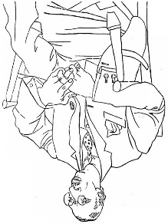 http://www.huffingtonpost.com/brian-d-cohen/drawing-from-both-sides-o_b_1205604.html
The idea behind training ourselves to use more of our brain is to force it to see something from different perspectives and use it in a different way than we’re used to. One of these techniques consists of taking a given drawing and copying it on plain paper upside down
At times, the drawings should not be shown to anybody at all or displayed. It will function as a personal experience where the student can be oneself instead of risking failure or feeling victory. Like a journal, there is no reason other than to explore who you are and discover oneself.

ART FOSTERS POSITIVE SOCIAL AND EMOTIONAL DEVELOPMENT AS WELL AS TEAMWORK
In many classrooms, however, students not only have a space to critique each others’ work, but also have the opportunity to collaborate with others on murals and other large art projects. Here, children learn about diverse views, and see that when their unique ideas are meshed with others, something can be created that otherwise one person couldn’t have possibly accomplished.
Bukkard, J. (2010) explained in his article, How the Art Center Enhances Children’s Development, that art may provide some of the emotional skills necessary for our students to function as well-rounded and happy individuals. “As children participate in art activities they gain self-confidence, feel pride in their work, and experience success” Art allows children to express strong emotions that they may have difficulty verbalizing. It may provide the child and others with insights into the child’s thoughts and feelings, thus allowing for conversation and further discussion.
PERFORMING ARTS IN THE CLASSROOM
Performing arts is an opportunity not to be missed especially in our Islamic schools. While a proper drama culture with a director, stage and costume design, auditions to find the stars of the show, and those who work backstage would be ideal for the creative students, it is not always possible to attain. Drama provides the students for a rich, fulfilling experience with addresses the social needs of the students, which is difficult to replace with any other experience. Similar to the other artistic expressions discussed, it is easily applicable to almost any discipline that can be imagined. One easy technique to use to offer some performing arts is to offer some time and space to extemporaneous speech about what they know about a subject. The student can pick a subject or term out of a bag and speak for one or two minutes only about that topic. They can also write and perform a dialogue about the subject in class. They can personify math, science, or grammar terms, and he or she can act like that term and talk to other terms. The prepositional phrase can appeal to the subject and verb telling them that they think the sentence is all about them, the nucleus can present a dialogue with the cell wall, or the world leader can talk to the workers or other leaders. This can fulfill an anticipatory set, priming the students for what will be learned and finding out what prior knowledge they have. It also can serve as a good review, making sure that they understand what was learned. Some useful tips I learned while attending a teaching Shakespeare workshop at Rutgers University last year are, while reading long passages in poetry or long monologues, break it up and assign the students to stand in different parts of the room and present their section. This can be applied to any long, mundane reading. Another is that groups of students can take any section of a story or history lesson and make a silent play, using only movements to demonstrate what the play or lesson is saying. The students will watch attentively to try to decode the message being shown and will be eager to share what they think it was.
My experience with teachers is that they don’t feel empowered to teach an art class. They simply feel that they can’t do it without art training. While some studies show that the biggest benefits are seen when formal instruction is given, the benefits that the students will reap by simply keeping supplies within the classroom and having some loosely instructed projects transform a classroom into a creative and open one where students can use their drawing tools as a form of expression. My daughter in fifth grade loves all things expression related. She loves to write, draw, and even express herself in her outfit choices. She goes to Islamic school, and was fighting with her sister whom she felt was copying her with the way she was wearing her uniform. She yelled that her sister is imposing on her individuality. I told her that there is no such thing as such a thing with uniforms, and the point of them is that everyone will look alike and not have their individual styles show. It was as if I broke the worst news of her life to her. This resulted in many tears as she covered her face and slumped to the floor. My point is, to some of these students, their art may be one of the only treasured measures that they feel they can express themselves through. Some of our students may feel their free spirits to be stifled in the rigidity of our practices in Islamic school. If there isn’t a teacher that can instruct and come around with an art cart to allow the students to use the various mediums, each classroom should have good quality markers (prismacolor), some oil pastels, soft pastels, colored pencils, black sharpies, acrylic paint, watercolor, scissors and different paper so that the students can finish their projects in their free time as well as start new ones and explore their creative minds.
Due to my class load, I only see my students every other week for a brief art period, and I don’t do as good a job as I feel I could if I had more time to research new projects, practice, and implement more from their curriculum so that it reinforces what they learn. This is implemented in the academic periods, and it would be possible for the teachers without an art background to do this themselves. Each year I try to add to what I already do. I am overwhelmed as I’m sure you are. This change, however, is worth it no matter how small the steps to becoming more art-integrated are. Understandably, implementing an art class if there is none requires an administrative buy-in or flexibility in scheduling, however, instilling regular art within your existing curriculum can happen tomorrow. Please don’t dismiss how a few hours spread over a month can change a student behaviorally, academically, and socially.

Bibliography
Bukkard, J. (2010, July 20). How the Art Center Enhances Children’s Development. Retrieved from http://www.education.com/reference/article/art-center-enhances-children-development/
Carneiro, Celeste. (2000). Art and the Brain in the Learning Process. Retrieved from http://www.cerebromente.org.br/n12/opiniao/criatividade2_i.html
Cohen, Brian. (2012, January 1). Drawing from Both Sides of Your Brain. Retrieved from
http://www.huffingtonpost.com/brian-d-cohen/drawing-from-both-sides-o_b_1205604.html
Henry, Tamara. (2002, May 19). Study: Arts Education has Academic Effect. Retrieved from http://usatoday30.usatoday.com/news/education/2002-05-20-arts.htm
Posner, Michael and Patoine, Brenda. (2009, September 14). How Arts Training Improves Attention and Cognition. Retrieved from http://www.dana.org/Cerebrum/2009/How_Arts_Training_Improves_Attention_and_Cognition/
Smith, Fran. (2009, January 28). Why Arts Education is Crucial, and Whos’s Doing it Best. Retrieved from http://www.edutopia.org/arts-music-curriculum-child-development

Vega, Vanessa. (2012, August 29). A Research-Based Approach to Arts Integration. Retrieved from http://www.edutopia.org/stw-arts-integration-research

