Ten Effective Steps to Teach Reading
Dr. Mona Hamdan and Amna Al-Sayed

Abstract
Reading is an important part to student learning. Students need to understand what they read and to be able to recall the main ideas when they need them. Many steps come together to help the teacher inside the classroom to let the students understand what they read. In this workshop, a short story will be distributed to the participants to practice the ten steps for teaching reading comprehension. Presenters will engage participants in learning how to structure their classroom while teaching reading that enable all students to actively participate in class.

About the Authors
Dr. Mona Hamdan is an academic vice principal and professional development coordinator at Arwa Independent Secondary School in Qatar. She taught Arabic, and Quran at Michigan Islamic Academy for 15 years. She has over 25 years’ of experience in USA and Qatar as a science, math, Arabic and Quran teacher, coordinator, professional development, student councillor, and academic vice principal. Dr. Hamdan has taught students of all ages and levels and trained a lot of workshops in Qatar, Dubai, Bahrain, and USA. Dr. Mona’s main specialization is Bachelor’s degree in Chemistry, Master in Science and PhD in leadership and Special Education. She is a certified trainer.
Sr. Amna Al-Sayed is a vice principal at Abi Hanifa Independent School in Qatar. She has over 20 years’ experience in Qatar as a teacher, coordinator, professional development, vice principal. She worked 15 years in middle and secondary schools and five years in early education. Al-Sayed has trained a lot of workshops in leadership, education and teaching strategies in the universities and conferences in Qatar, Dubai, and Bahrain. Amna’s main specialization is Bachelor’s degree in Math and she is a certified trainer.

Ten Effective Steps to Teach Reading
Reading with understanding means students need to know enough words and their meanings so they can understand what’s going on. Sometimes students spend a lot of time reading something before they understand it or they might not even understand it. In this workshop, we will go over ten steps that make the student have fun and comprehend with the teacher in the reading class. These steps will help student to become an active reader and will improve text comprehension.
An Arabic short story will be distributed to the participants and ten effective comprehension steps will be used through cooperative learning, to involve the participants to work together in small groups on the task that will be assigned each time. Participants will work together to understand texts, help each other learn and apply comprehension.
Participants will work together in groups for each activity and each group will discuss their answers at the end of each activity. So in this workshop, we will model a lesson as it is given in the classroom by reading a story, getting the main idea, guessing, imagining, asking questions, writing new vocabularies and their meanings, clarifying make connection, comparing and summarizing.
Inside the classroom the teacher will use the ten steps while applying any lesson of reading to develop reading skills and understanding for the students. The ten steps are:
- Making connections: the students will be asked to connect the text with the personal life of the student or with different texts that was read before.
- Ask questions: the students will be asked questions based on the information that are in the text to make sure the students’ understanding of the text.
- Clarifying vocabulary: Determine the meaning of the new vocabulary words.
- Predicting: Think about title, what do you think will happen?
- Visualizing: use our senses and emotions, picture the characters, setting, events
- Determining important ideas: Identify the most important ideas covered in the text, if the students figure out what is the main idea of the text that means that they understood it.
- Making interferences: to draw conclusions, make predictions, and reflect on the part that you read. Example: What is the author’s message to us from this text.
- Summarizing: use summarizing to check understanding by asking the students to summarize what they read in their own words.
- Check and make sure of understanding: make sure that the text is clear and that the ideas reached to all students, review the main ideas in the text,
- Fluency: Teacher chooses one student to read fluently with speed, accuracy and proper expression.
It will be a great workshop because reading is supposed to be enjoyable. The comprehension skills that the participant will take to their class will develop the students understanding, ideas and concepts they are reading.
Conclusion
The ten steps for teaching understanding foreign language reading will be helpful for the teacher and the students. We hope that our ten steps will give teachers support to help their students become proficient foreign-language readers.

نص قراءة
قراءة : درس طريق الخير من كتاب الصف السادس :
اقرأ النص التالي لدرس طريق الخير جيداً:
(( طريق الخير ))
بعد أن فرغ أفراد الأسرة من صلاة العشاء ، أخذ الجد مكانه المعتاد من المجلس ، وبين يديه حفدته ينتظرونه لسماع إحدى حكاياته الجميلة كعادتهم كل ليلة جمعة . وحين استقر به المقام مد بصره ، وكأنه يستجمع شتات أفكاره، ثم شرع يقص حكايته قائلاً : في قديم الزمان كان رجل طيب القلب اسمه ((عبدالله )) يعيش مع زوجته وأبنائه في يسر ورخاء ، يقضي معظم وقته في خدمة أرضه ورعي أغنامه. وفي إحدى السنوات قلت الأمطار وجفت المراعي ، فراح عبدالله يبحث عن مصدر آخر للماء يروي به أرضه.
وبينما كان يجوب المناطق المجاورة لأرضه في يوم من أيام الحر- وقد أخذ منه التعب مأخذه- تراءت له صخرة كبيرة فاتجه نحوها لينال قسطاً من الراحة . ولما بلغها لمح تحتها فتحة ضيقة ، فإذا هي بئر مهجورة قد انتصبت فوقها الصخرة فحالت دون الانتفاع بمائها.
أرسل عبدالله دلواً كانت معه ليختبرعمق البئر ووفرة مائها ، ولما أراد إخراج الدلو لقي صعوبة واسكب معظم ما فيها من ماء بسبب تلك الصخرة .
ظل عبدالله يختلف إلى البئر ، فلا يحصل من مائها إلا على القدر اليسير ، حتى عرف الناس منه ذلك ، فصاروا يقبلون على البئر ولا ينالون أكثرمما يناله .
جلس عبدالله ذات يوم وقال في نفسه : (( لولا تلك الصخرة التي تسد البئر لاتخذت دلواً أكبر ، فحصلت على ماء أوفر ، ولكن كيف لي بذلك ، وهذه الصخرة الكبيرة تمنع الماء عني وعن غيري ، وما من أحد يقوى على إزاحتها بمفرده ؟
ازدادت- يا أحفادي - حيرة عبدالله ومخاوفه وهو يرى زرعه يذوي وأغنامه تهزل ، ثم خطر بباله تساؤل : ماذا لو اجتمع على إزاحة هذه الصخرة كل الذين يختلفون إلى البئر؟ استحسن عبدالله الفكرة ، فظلت تشغل باله طول يومه .
ومن الغد استيقظ مبكراً ، وسارع إلى البئر ينتظر الواردين ، وكلما أقبل عليه أحدهم ، عرض عليه الفكرة فأيدها ....ثم أنهم اجتمعوا حول البئر ، فأحاطوا بالصخرة يريدون دفعها بأيديهم ، لكنها لم تتزحزح .
أحضر عبدالله حبالاً غليظة لف بها جنبات الصخرة ، ثم طلب إلى فريق منهم أن يشدوا الحبال
بعزم وقوة ، بينما تابع اللآخرون دفع الصخرة وصاحوا جميعاً صيحة رجل واحد (( يا الله ... يا
معين )) فإذا الصخرة الجاثمة تتباعد ، وإذا الفتحة تتسع ، فيزداد عزم الرجال على إزاحتها بعيداً عن البئر.
شعر الجميع بالفرحة ، وشرعوا في نقل الماء إلى مزارعهم ، وبمرور الأيام ارتوت الأرض ، واستوى الزرع ، وعم الخصب ، فتوجهوا إلى الله بالشكر والثناء .
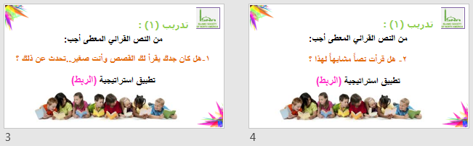
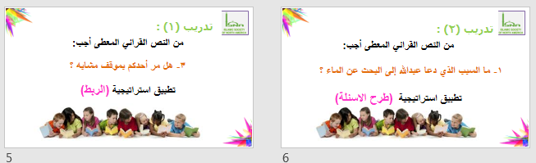
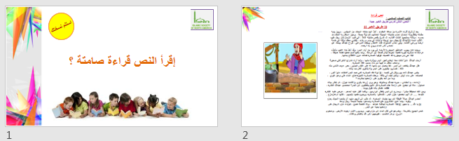

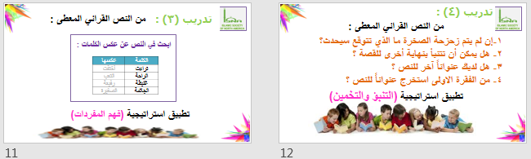
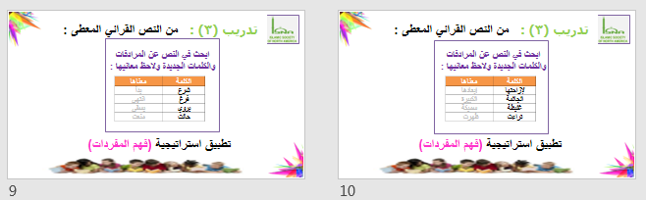
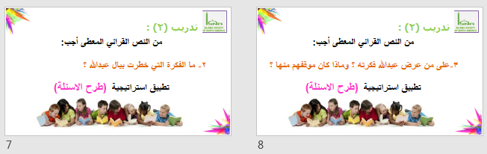
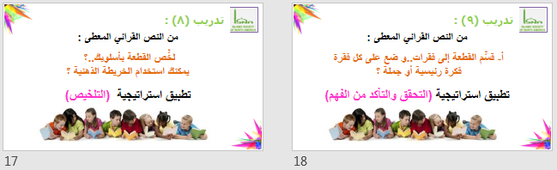
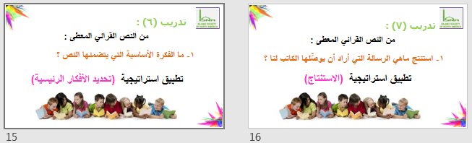
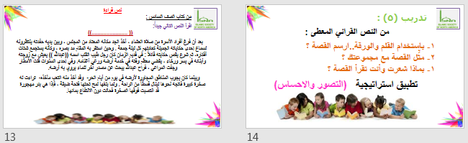

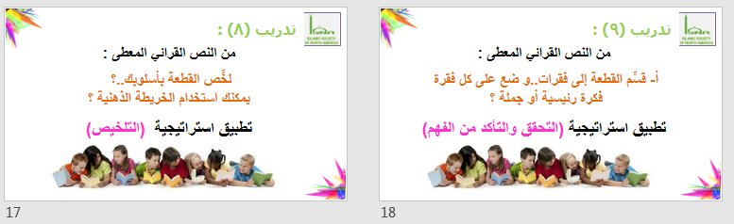
References
Adler, C.R. "Seven Strategies to Teach Students Text Comprehension." Reading Rockets. N.p., n.d. Web. 09 Feb. 2017.
Hilal, Ali. “Arabic Book for Six Grade.” Ministry of Bahrain. Seventh edition, 2013.
"Ten Top Reading Comprehension Strategies for Teaching Elementary and Middle School Students." Teaching Writing Fast and Effectively. N.p., n.d. Web. 09 Feb. 2017.

