Reimagining the Science Classroom: One Verse at a Time, Muslim Scientists of the Golden Age, and their Impact Today

Abeer Saleh

MCC Academy

Abstract

Our youth today are in need of understanding and appreciating the significance of verses from the Quran and the accomplishments of our Muslim ancestors in the secular education. How can we have students grasp the eminence of the verses from the Quran when learning science in the secular education? How can we help them gain knowledge about the Golden Era in our history when Islam was at its peak in the advancements of all areas of science that impact us today? This can be achieved through one verse at a time to our youth and presented with the science behind the verse, fun facts, and engaging hands on activities that correlate to the Next Generation Science Standards.

Speaker Biography

Abeer Saleh is a Middle School Science Teacher and Department Head at MCC Academy in Morton Grove, Illinois. She has been teaching for nearly twenty years in both the Chicago Public School System and Private sector. Abeer Saleh is currently the Department Head of the middle school and spearheads the Science Olympiad competition, Science Fair Competition, and the Quran and Science class for eighth grade students at MCC Academy. Mrs. Saleh has been a guest panel speaker at Inter-Faith programs for her local community and featured in the Champion Newspaper. She began the class ‘Quran and Science’ at MCC Academy, which led her to author a book with the help of HQ Consulting titled, “One Giant Step for Mankind, One Verse at a Time”. Abeer Saleh is in collaboration with Pearson Publishing Company, which will include chapters of her book in the science curriculum. Her two children are a product of MCC Academy and all currently reside in Morton Grove, Illinois.

Introduction

If we were to reimagine our science classroom as a place of learning that ties lessons with knowledge of the Quran and our Muslim predecessors that contributed greatly with our current advancements in science, it can be a whole new insight for our new generation of students to embark on while learning in the secular part of our science curriculum. This paper is intended to offer practical suggestions for educators to use in the classroom. There are multiple verses from the Quran correlating to a specific area in science that can be used as a cross-curricular approach to teaching. Connecting the Muslim Scientists during the time of the Golden Era and with what is being taught in the secular science curriculum can be addressed in a classroom. All students are able to revel in learning ‘fun facts’ when being taught about the connections made when teaching verses from the Quran and science. Providing hands-on lab activities correlating to the Next Generation Science Standards can be parallel to the verses of the Quran and the Muslim Scientists during the Golden Era. Fostering students’ creativity through their learned knowledge and allowing them the opportunity to do da’awa for the community is of great significance that can empower our youth and build on their confidence.

Review and Practice
Howard Gardner, an educationalist, psychologist, and neurologist is argued by some to be amongst the most influential of Western thinkers on education. He believes, ‘any topic of significance can, and should, be represented in a number of different ways in the mind’ (Gardner, 2004: 141). There is plenty of educational research and general advice on how to enhance the learning experience of a child, but very few practical models on how to incorporate practices in the classroom. Cross-curricular instruction offers a particular set of values and attitudes, especially when introducing the connected web of Quran and science in Islamic Schools.
Practice:
In the area of life science, a lesson that is typically taught is on the understanding of cell structures. Let us look at the area of embryology and determine the connection to a verse from the Quran, science behind the verse, a Muslim Scientist during the time of the Golden Age, fun facts in connection to this study, a hands-on science lesson targeting the Next Generation Science Standard, and review questions that can be used for discussion. After the culmination of the lessons being taught, the students are given the opportunity to create their own written scripts with adhering to a teacher made rubric and present their plays for their local community.
In the beginning of a secular science instruction on cells, for example, and the understanding of mitosis and meiosis, a verse is introduced that will tie into that area of science.
Verse from the Quran:
In Surah Az-Zumar (The Troops) verse number 6:
خَلَقَكُمۡ مِّنۡ نَّفۡسٍ وَّاحِدَةٍ ثُمَّ جَعَلَ مِنۡهَا زَوۡجَهَا وَاَنۡزَلَ لَـكُمۡ مِّنَ الۡاَنۡعَامِ ثَمٰنِيَةَ اَزۡوَاجٍ​ ؕ يَخۡلُقُكُمۡ فِىۡ بُطُوۡنِ اُمَّهٰتِكُمۡ خَلۡقًا مِّنۡۢ بَعۡدِ خَلۡقٍ فِىۡ ظُلُمٰتٍ ثَلٰثٍ​ ؕ ذٰ لِكُمُ اللّٰهُ رَبُّكُمۡ لَهُ الۡمُلۡكُ​ ؕ لَاۤ اِلٰهَ اِلَّا هُوَ​ ۚ فَاَ نّٰى تُصۡرَفُوۡنَ‏

He it is Who created you from a single being, and He it is Who made from it its mate. He it is Who created for you eight heads of cattle in pairs. He creates you in your mothers' wombs, giving you one form after another in threefold depths of darkness. That, then, is Allah, your Lord. His is the kingdom. There is no god but He. So, whence are you being turned astray?

Science behind the Verse:

About a century ago, people thought that a baby developed only in the womb of its mother in a single dark zone. In this verse, Allah (S) says: "He has created your mother's womb in three kinds of darkness, passing from one genesis to the next." What are these three kinds of darkness?

First Dark Zone:
This is the zone where a zygote (two cells containing 23 chromosomes each from both mother and father making it 46 chromosomes altogether) is formed and travels through the fallopian tube of the mother. The zygote will measure approximately 0.005 inches in diameter and weighs about 0.005 ounces. This is not visible to the human eye! The chromosomes already carry the intricate details mapping out the genetics of the soon- to -be baby. Will he/she have brown hair, blue eyes, lobed ears, widow's peak, etc?
Second Dark Zone:
This is the zone where the zygote has found a resting spot in the intrauterine epithelium (endometrium). Here is where the beginning phases of organs are formed in what will now become an embryo from the second week of development through the eighth week of development. Cell division occurs creating the detailed parts forming the baby.
Third Dark Zone:
This is the zone where the amniotic sac containing a special fluid that acts almost like a soft pillow will cushion around the embryo. The organs and physiological systems start developing within the amniotic sac. Starting at the ninth week of development, it is now called a fetus and can move as freely as possible within the walls of the uterus from the protection of the amniotic sac.
Keith Moore, a professor in the division of anatomy, is famous in the Muslim community as the man who gave recognition to the Quran on the verses. In 1980, Moore says, “For the past three years, I have worked with the Embryology Committee of King Abdulaziz University in Jeddah, Saudi Arabia, helping them interpret the many statements in the Quran referring to human reproduction and prenatal development. At first, I was astonished by the accuracy of the statements that were recorded in the 7th century, before the science of embryology was established.”
Now, some may argue that Aristotle already claimed the idea of how life was first created. He studied embryos of different organisms by opening up bird eggs at different stages of development. Aristotle argued that semen supplied the form or breath to embryos and mothers supplied some type of substance to aid in embryonic development. He used the term ‘spermados,’ which means the actual physical fluid or semen. But the word ‘nutfa’ in the Quran is a singular form for the term used of that which we call sperm. This ayah is specifically mentioning the phases in order of which life began from a single ‘nutfa’ or sperm. The study of embryology was not even existent during the time of the Prophet, peace be upon him. To learn of this knowledge and explicitly describe the stages of the development of life in the Quran can only be from the divine. Eventually, from these stages you have the birth of an entirely unique individual that possesses his or her own DNA code. DNA, the molecule that contains genetic information for an individual, is so amazing that it can hold entire libraries of information in its double stranded structure. Additionally, DNA is such a unique marker for an individual that even identical twins do not share the same DNA. This entire DNA emerges from the union of a sperm and an egg, as they travel through the three zones of darkness.
Connection with a Muslim Scientist during the Golden Age:
Ibn Sina (980- 1037)
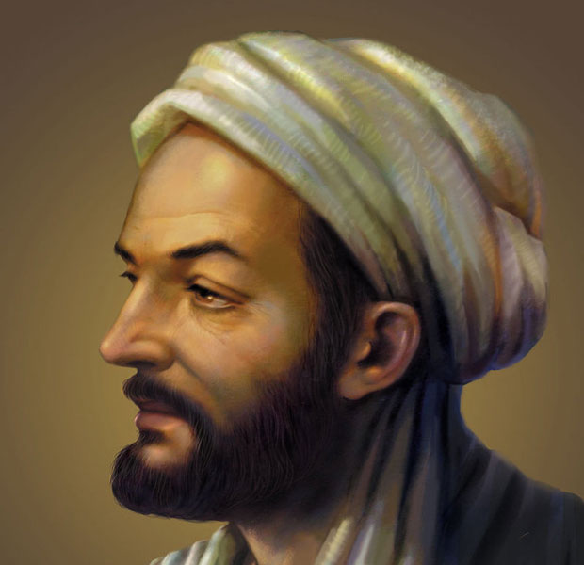
Famousphilosophers.org

Ibn Sina was born in present day Uzbekistan. He was a Persian scientist that sought knowledge from when he was a very young child. He memorized the entire Quran by the time was only seven years old. When he reached the age of eighteen, he became a successful doctor working in the same town as Al-Razi (a Muslim scientist who worked in the 9th century in a Baghdad hospital named Al-Qayrawan in the ward for the mentally ill).
Some people would perhaps go to study medicine and fear it. Some may dislike the study, but pursue it for the degree. Ibn Sina had a genuine passion for studying medicine. Nowadays, doctors prescribe medicine and the pharmacists prepare it for patients. Ibn Sina would prescribe and make the medicine himself for his patients making sure to give the best care for each individual. Much thought and attention was given to his patients and his teachings continued on throughout the centuries by way of his most infamous book, Canon of Medicine. In terms of pregnancy, Ibn Sina correctly stated that the fetus develops from the mother’s blood and thus it is important for the mother to make sure she is getting the correct nutrients. This is a practice we still follow currently. The Canon was reproduced as fifteen Latin editions during the 15th century and translated into Hebrew, which had a major impact on Jewish medical practice. It was the basis of the curriculum used in medical schools throughout Europe to perform surgery and deliver babies safely in the case of complications.
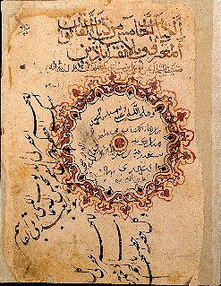
Ibn Sina’s medical text from the 1000’s AD
Historyforkids.org

“Fun Facts”
Every human being shares 99% of his/her DNA with every other human. DNA is the 'blueprint' of life and is found in the nucleus of cells. If you put all the DNA molecules in your body end to end, the DNA would reach from the Earth to the sun and back over 600 times. Red blood cells do not have DNA in them. DNA is one argument that evolution supporters use to support the idea that humans evolved from chimpanzees since they share so much DNA in common. However, as Muslims we see that we share DNA with every living thing not just chimpanzees, and that this is a sign that we all come from the same Wise Creator.
One hoax of evolution, which is very famous, is known as Piltdown man. In 1912, Charles Dawson found a skull and a jawbone in Piltdown, East Sussex England. He called it "The Piltdown Man" and claimed that it was the remains of a previously unknown early human. Many evolutionists/Darwinists were thrilled to hear the news! But all that came to an end in 1953 when it was exposed as a hoax. The lower jawbone of an orangutan was deliberately combined with the skull of a fully developed modern human. People believed this hoax for almost 40 years! As Muslims, we know that human beings are a uniquely designed creation with a higher purpose, which no other DNA containing creature can fulfill.
Hands-on lesson culminating this area of study:
Next Generation Science Standard:
MS-LS1-3. | Use argument supported by evidence for how the body is a system of interacting subsystems composed of groups of cells. [Clarification Statement: Emphasis is on the conceptual understanding that cells form tissues and tissues form organs specialized for particular body functions. Examples could include the interaction of subsystems within a system and the normal functioning of those systems.] [Assessment Boundary: Assessment does not include the mechanism of one body system independent of others. Assessment is limited to the circulatory, excretory, digestive, respiratory, muscular, and nervous systems.]

Extracting DNA (Deoxyribonucleic acid) from Strawberries

Materials:
- Heavy- duty Ziploc bag
- One strawberry
- 10mL DNA extraction buffer (900mL water, 50mL dishwashing detergent, 2 teaspoons salt)
- Large beaker to place the buffer
- dishwashing liquid
- cheesecloth
- funnel
- 50mL vial/test tube glass
- inoculating loop or popsicle stick
- 20 mL ethanol
Procedure:
1. Place one strawberry in a Ziploc bag.
2. Smash/grind up the strawberry using your fist and fingers for 2 minutes being careful not to break the bag.
3. Add the provided 10mL of extraction buffer (salt and soap solution) to the bag.
4. Kneed/mush the strawberry in the bag again for 1 minute.
5. Assemble your filtration apparatus by placing the cheesecloth over the funnel and the funnel into the test tube glass
6. Pour the strawberry slurry into the filtration apparatus and let it drip directly into your test tube.
7. Slowly pour cold ethanol into the tube. OBSERVE
8. Dip the loop or popsicle stick into the tube where the strawberry extract and ethanol layers come into contact with each other. OBSERVE
You should observe a gooey substance when placing the inoculating loop or popsicle stick into the test tube. This is the DNA of the strawberry. By using the solution and adding ethanol, you are initially breaking open the proteins and dissolving cell membranes of the strawberries to extract the DNA. Strawberries are octoploid, meaning that they have eight copies of each type of chromosome.

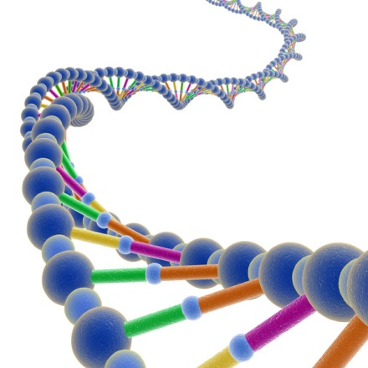
Image taken from truthfall.com

Questions for Understanding
- Why do you think the embryo is always so well protected during its development within the womb?
- What are the three layers according to the Quran that the embryo develops within? Explain the function of each level.
- What is the importance of DNA to the human being?
- Why do you think even identical twins do not share the same DNA?
- How is DNA able to hold more information than a library of books within its simple double helix structure?

Student developed skits:
Students collectively collaborate on the lessons that were taught and develop a creative script using their prior knowledge from the verses learned and the Muslim Scientists of the Golden Era. They are given the opportunity to share their knowledge, reenact a Muslim Scientist, and foster a da’awa opportunity for their local community.

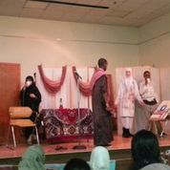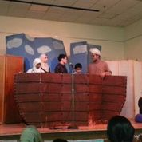

Conclusion
Robert Heinlein, an American science-fiction writer known as the “dean of science fiction, is famously known for his quote, ‘When one teaches, two learn’. It is our duty as educators to provide any opportunity to instill motivation and self-confidence in our students. Through plays and using the imagination, students may perhaps remember lessons in science through a deeper sense and value the meaning of the Quran, one verse at a time.

Landi, M. A., & Calamari, E. (2004). Howard Gardner: Da "frames of mind" a "intelligence reframed: Tesi di laurea. Pisa.
Moore, K. L. (1983). The developing human: Clinically oriented embryology. Saudi, Arabia: Dar Al-Qiblah for Islamic Literature.
Pinning Down Piltdown - ncse.com. (n.d.). Retrieved November 13, 2016, from https://ncse.com/printpdf/18344

